Name………………………………………………… adm no. ……………class…….

School ………………………………………………...

231/1
BIOLOGY
PAPER 1
Sept 2021
Time: 2 HOURS

KASSU JET EXAMINATION -2021

231/1
BIOLOGY PAPER 1
Time: 2 HOURS
Sept 2021

INSTRUCTIONS TO CANDIDATES
- Answer ALL the questions.
- Answers must be written in the spaces provided in the question paper.
- Additional pages must not be inserted.
- The paper consists of 14 printed pages.

FOR EXAMINERS USE ONLY
Question | Maximum score | Candidate’s score
1-29 | 80

This paper consists of 13 printed pages. Candidates should check the question paper to ascertain that all the pages are printed as indicated and no questions are missing
- How does growth as a characteristic of living organisms differ in plants and animals ?

(2marks)
………………………………………………………………………………………………………………………………………………………………………………………………………………………………………………………………………………………………
- a)State the role of active transport in animal nutrition (1mark)
………………………………………………………………………………………………………………………………………………………………………………………………………………………………………………………………………………………………
b) Cyanide lowers the rate of active transport. Explain? (2marks) ………………………………………………………………………………………………………………………………………………………………………………………………………………………………………………………………………………………………
- The figure below is a diagram of a vertical section of a mammalian tooth.
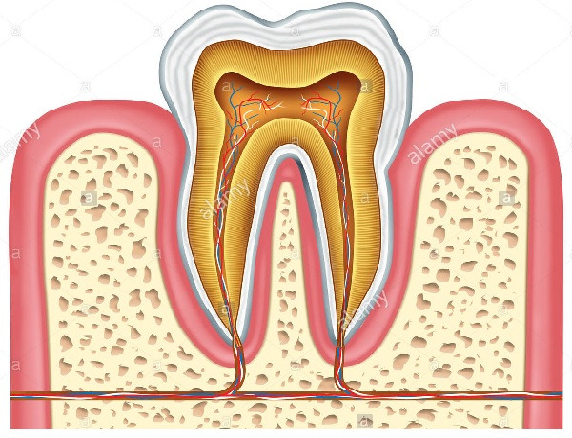
A
B
D
(i) Name the part labelled A and B. (2 marks)
A ………………………………………………………………………………………………
C ………………………………………………………………………………………………
(ii) State two ways in which structure D is adapted to its functions. (2 marks)
………………………………………………………………………………………………………………………………………………………………………………………………………………………………………………………………………………………………
(iii) List two ways of preventing gingivitis. (2 marks)
………………………………………………………………………………………………………………………………………………………………………………………………
- The figure below shows % saturation of oxygen in blood in fish as water passes along the gill plate.

% saturation of oxygen
Water
Blood

Distance along the gill plates

(a) (i) Name the type of blood flow shown in the gill plate. (1mark)
……………………………………………………………………………………………… (ii) Explain the advantage of the type of flow named in a (i) above (2marks)
………………………………………………………………………………………………………………………………………………………………………………………………………………………………………………………………………………………………
(b) State two organs in humans which display the type of flow named in a (i) above (2marks)
………………………………………………………………………………………………………………………………………………………………………………………………………………………………………………………………………………………………
(c) State two ways in which floating leaves of aquatic plants are adapted to gaseous exchange (2marks) ………………………………………………………………………………………………………………………………………………………………………………………………………………………………………………………………………………………………
- The equation below shows an oxidation reaction of food substances.
C₅₁H₉₈O₆ + 145O2 ------- X CO2 + 98 H2O + energy
a) What do you understand by the term respiratory quotient? (1mark)
………………………………………………………………………………………………….……………………………………………………...……
b) Determine respiratory quotient of the oxidation of food substance. (2marks)

c) Identify the food substances. (1mark)
…………………………………………………………………………………
- When any one of the growth parameters such as growth in size or weight, increase in number of cells are plotted in a graph against time like below, a clear curve is obtained
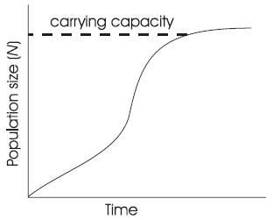
State its name……………………………………………………….................... (1mark)
- The graph below represents the growth in a certain phylum.
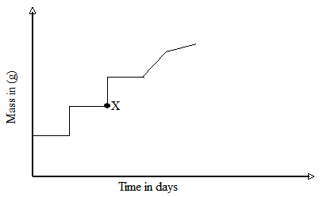

How does this differ from growth in humans? (1mark)

………………………………………………………………………………………………………………………………………………………………………………………………
- The embryo of a dry, fully developed seed usually passes through a period of rest after ripening period and it cannot germinate even when provided with all favorable conditions. State the significance of this. (2marks)
……………………………………………………………………………………………………………………………………………………………………………………………………………………………………
- a) Cowpeas seeds were place in a vacuum flask and left for five days. What is the expected change in composition of gases in the flask on the sixth day? (1mark)

…………………………………………………………………………………………………
b) Give a reason for your answer in (a) above (1mark)
…………………………………………………………………………………………………
- Biotechnologist works day a night to curb food insecurity using the knowledge of polyploidy in genetics. Explain the economic importance of such practice? (2marks)
………………………………………………………………………………………………………………………………………………………………………………………………………………………………………………………………………………………………………………………
b) Define a backcross? (1 mark)
………………………………………………………………………………………………………………………………………………………………………………………………………………

- The structure below was obtained from an animal cell
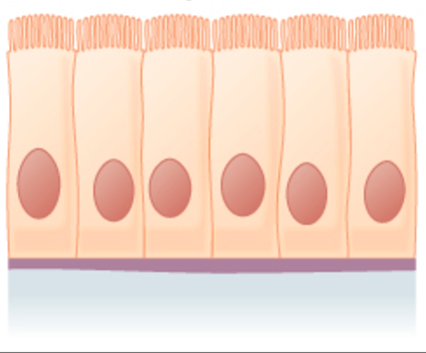
- What is the name of the hair like processes and state its function? (2marks)
Name
…………………………………………………………………………………………..
Function
…………………………………………………………………………………………..
- From which parts of the mammalian body are these structures found? (1mark)
…………………………………………………………………………………………..
- State the effect of cigarette smoking to the structure? (1mark)
……………………………………………………………………………………………………………………………………………………………………………………………....
12. A student was found to have blood group B+
a) What type of antibody is present in his plasma? (1mark)
…………………………………………………………………………………
b) Which antigens are present in this blood group? (1mark)
………………………………………………………………………………….
- Plants relatively have less waste to excrete than animals. Give two reasons to explain this observation (2marks) ………………………………………………………………………………………………………………………………………………………………………………………………………………………………………………………………………………………
- State two methods by which plants get rid of their waste products (2marks)
………………………………………………………………………………………………………………………………………………………………………………………………………………………………………………………………………………………………………
- To estimate the population size of mosquitoes in Banji village that covers an area of 25km², visiting researchers caught 400 mosquitoes which they marked and released. After 24 hours, 200 mosquitoes were caught out of which 120 had not been marked.
(a) Suggest the sampling method described above. (1 mark)
………………………………………………………………………………………………
(b) What are the disadvantages of this method? (2 marks)
……………………………………………………………………………..………………………………………………………………………………………………………………………..……………………………………………………………………………………………………………………………………………………..…………………………

16. The table below shows stomatal distribution on leaves A and B and their surface area. Use the information to answer the questions.
 | Leaf surface | A | B
Number of  stomata | Upper leaf  surface | 20 | 5
Number of  stomata | Lower leaf  surface | 0 | 15
Surface area |  | 25 cm² | 18cm²
Identify with reasons the habitats of the plant from which the leaves were obtained.
Leaf A: (2 marks)
Habitat ……………………………………………..….…………..…………..
Reason ……………………..………………….…..….….…..……………….
………………………………………..………………………………
Leaf B: (2 marks)
Habitat ………………...……………………………………………………………
Reason ………………………………………………………………………………
……………………………………………………………………………
17. Name the causative agent of the following diseases (2 marks)
(i) Trichomoniasis.
………………………………………………………………………………………………
(ii) Gonorrhea
………………………………………………………………………………………………

18. The diagram below shows a pollen tube as it develops down the style. Use it to answer the questions that follows;
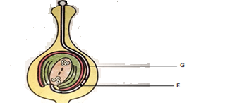
(i) Name the part labelled G. (1 mark)
………………………………………………………………………………………………
(ii) State two functions of structure labelled E. (2 marks)
………………………………………………………………………………………………………………………………………………………………………………………………
19. (a) Define parthenogenesis? (1 mark)
………………………………………………………………………………………………………………………………………………………………………………………………
(b) Name the plant hormone that induces fruit ripening. (1 mark) ………………………………………………………………………………………………
20. A group of Form Three students collected a certain specimen for study as shown below. Study it carefully and use it to answer the questions that follow.
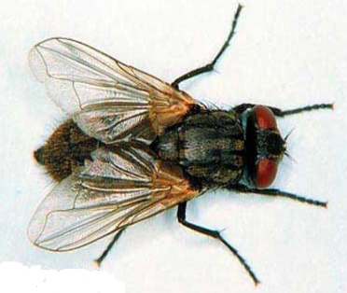
(i) Name the type of metamorphosis in the above specimen. (1 mark)
………………………………………………………………………………………………

(ii) Give any two advantages of the above metamorphosis. (2 marks)
………………………………………………………………………………………………………………………………………………………………………………………………
21. (i) Give two structural features in a leaf that adapts it to absorb Carbon (IV) Oxide. (2 marks)
………………………………………………………………………………………………………………………………………………………………………………………………
(ii) Name the cell organelle in which Carbon (IV) oxide combines with water to form a complex organic compound takes place (1 mark)
………………………………………………………………………………………………
22. In an experiment to investigate a factor affecting photosynthesis; leaf of a potted plant, which had been kept in the dark overnight was covered with an aluminum foil as shown in the diagram below. The set up was kept in the sunlight for three hours after which a food test was carried out on the leaf.
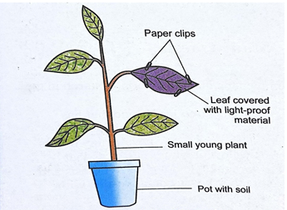
(a) Which factor was being investigated in the experiment? (1 mark)
………………………………………………………………………………………………
(b) Which food test was carried out? (1 mark)
………………………………………………………………………………………………

(c) State the results of the food test. (1 mark)
………………………………………………………………………………………………………………………………………………………………………………………………
23. Explain how the following plant adaptations minimizes rate of transpiration (2marks)
a) Sunken stomata
………………………………………………………………………………………………………………………………………………………………………………………………
………………………………………………………………………………………………
b) Thick cuticle
………………………………………………………………………………………………………………………………………………………………………………………………………………………………………………………………………………………………
24. Explain how drooping of leaves on a hot sunny day is advantageous to a plant (2marks)
………………………………………………………………………………………………………………………………………………………………………………………………………………………………………………………………………………………………
25. Name two tissues in plants which are thickened with lignin (2marks)
………………………………………………………………………………………………………………………………………………………………………………………………………………………………………………………………………………………………
26. The diagram below shows the front view of a male reproductive system.
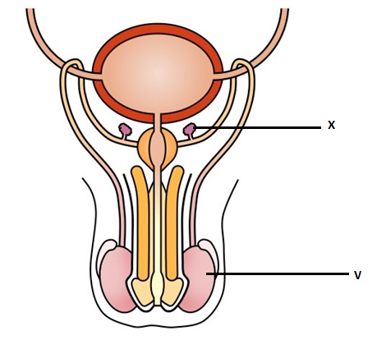
- Give the functions of the structures labelled X and V (2marks)
X
………………………………………………………………………………………………………………………………………………………………………………………………

V
………………………………………………………………………………………………………………………………………………………………………………………………
- What is the role of Follicle Stimulating Hormone in male reproduction? (1mark)
………………………………………………………………………………………………………………………………………………………………………………………………
27. Explain why the concentration of insecticides in fish eating birds may be hundreds of times greater than its concentration in the water where the fish live (3marks)
………………………………………………………………………………………………………………………………………………………………………………………………………………………………………………………………………………………………………………………………………………………………………………………………
28. The diagram below shows a stage in meiosis

State the biological significance of the stage represented on the diagram above (1mark)
……………………………………………………………………………………………………………………………………………………………………………………………………………………………………………………………………………………………….
29. How do the following factors hinder self-pollination in flowering plants? (3marks)
a) Self-sterility
………………………………………………………………………………………………………………………………………………………………………………………………
b) Heterostyly
……………………………………………………………………………………………………………………………………………………………………………………………………………………………………………………………………………………………..
c)Protogyny
………………………………………………………………………………………………………………………………………………………………………………………………………………………………………………………………………………………………

