KASSU 2021 BIOLOGY PAPER 3 MARKING SCHEME

1.You are provided with the photomicrograph of an onion outer epidermis as seen under light microscope

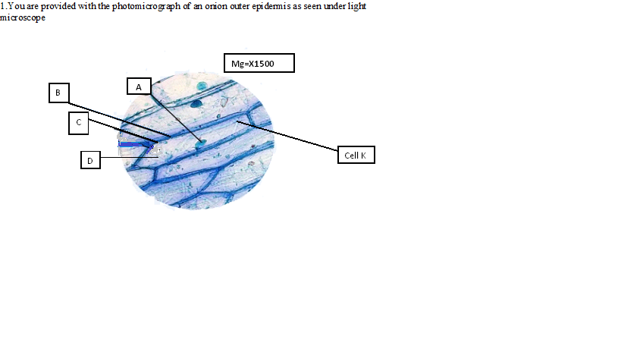
a) On the photograph, name parts labelled A, C, and D (3marks)
A chloroplast ;
C cell membrane ;
D cytoplasm ;
- Explain how the part labelled B is adapted to its function (2marks)
Cell wall contain the polysaccharide cellulose; that give mechanical support
- Calculate the actual size of the cell marked K, give your answer in micrometres
(2marks)
Mg = image size
Actual size
1500= 4.4×10,000 ;
Actual size
=44000
1500
=29.3um ; units
- The differences between the cells in the photograph and those obtained from an animal epithelial cells (3marks)
Onion epidermal cells | Animal epithelial cells
Cell wall present | Cell wall absent ;
Chloroplast present | Chloroplast absent ;
Nucleus located at the periphery | Centralised nucleus ;

- State the process that make the structures in the cell above appear more distinct (1mark)
Staining ;
- In microscopic procedure in 1 (e) above name what was used to achieve the process (1mark)
Iodine stain,;methylene blue ;eosin accept any one
2. The photographs below represent specimen labeled A, B, C and D

SPECIMEN A | SPECIMEN B
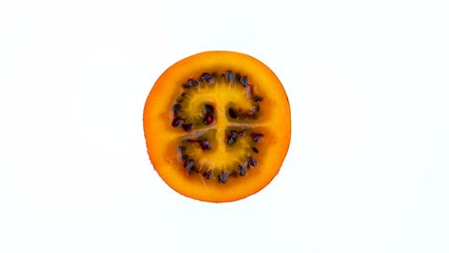 | 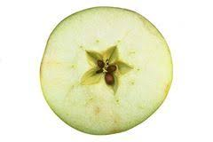
SPECIMEN C | SPECIMEN D
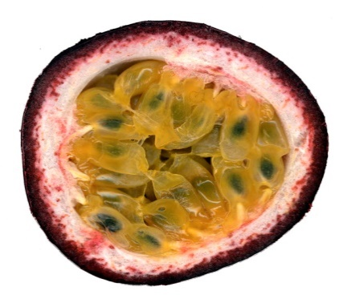 | 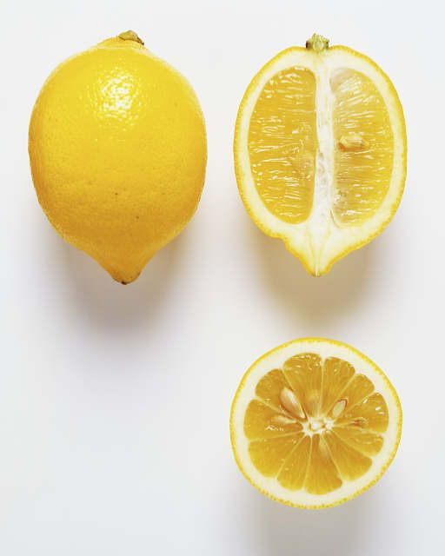
- Name the type of placentation shown in specimen A and B (2 marks)
A Axile;
B free central;
- Identify the type of sections from which specimen C and D was obtained?
(2 marks)
C cross section/transverse section;
- Longitudinal section;
- Classify the above specimen labeled D (1mark)
Succulent;
- You are provided with specimen labeled D1, D2, D3 and D4. Examine them
Draw and label specimen labeled D2 (3marks)
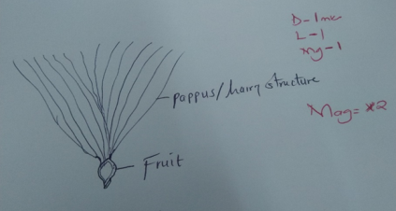
- Giving a reason and state the agent of dispersal of the specimen (6marks)
Specimen | Agent of dispersal | Reason
D1 | Animal ; | Have hook-like structures which stick on fur/clothes of passing animals;
D3 | Wind; | Has wing like structures to increase surface area for it to be carried by wind;
D4 | Animal ; | Brightly coloured, succulent to attract animals that feed on it;

3. You are provided with the following. Solution P, Q and Z.
- (i) Put 2 cm3 of solution P into two test tubes labeled A and B. Add iodine solution drops into test tube A. Observe and record. (1 mark)
Blue-black colour observed;
(ii)To test tube B, add an equal amount of Benedict’s solution. Heat to boil. Record your observation. (1 mark)
Blue-black of Benedict’s solution persist;
(iii) From the results in (a) (i) and (ii), Identify solution P. (1 mark)
Starch solution;
(iv) put 2cm3 of solution Z into a clean test tube labelled C. Add equal volume of Benedicts solution. Heat to boil. (1 mark)
Blue colour of Benedict’s solution persist;
(v) Open the visking tubing provided. Pour solution P into the visking tubing and add 1cm3 of the solution R. Tie the visking tubing and ensure there is no leakage. Pour solution Z into a clean beaker till it is half full. Immerse visking tube in the solution Z in the beaker. Allow it to stand for 30 minutes. After 30 minutes, take 2cm3 of solution Z from the beaker into a clean test tube labelled D. Add equal amount of Benedict’s solution. Heat to boil. Record your observation. (1 mark)
Colour changes from Blue-green- yellow- orange;
(vi)Account for the observation made in (v) above. (3 marks)
Starch is hydrolysed into maltose by enzyme diastase; maltose molecules are small enough to diffuse through the small pores of the visking tubing; maltose reacted with Benedict’s solution producing an orange colour;
- (i)Pour 2 cm3 of solution Q into a clean test tube. Observe and record the color of solution Q. (1 mark)
White/turbid/ cloudy;
(ii)Add 1 cm3 of sodium hydroxide into test tube containing solution Q. Record your observation. (1 mark)
Solution Q clears/ white colour fades off;
(iii)Explain the results observed in (b)(ii) above. (2 marks)
` Sodium Hydroxide breaks down the protein molecules into peptides; peptides form a clear solution;
iv). what is the identity of solution R? (1 mark)
Enzyme/diastase
v) State one factor that can affect the process demonstrated in 3a (v) above (1 mark)
Increase in temperature

