MANGU HIGH SCHOOL
Name………………………………………….....………Index no……………………..
candidate’s signature …………………
Date…………………………….

Biology 
Paper 3
OCT/NOVEMBER 2021
Time: 2hours
MANGU HIGH SCHOOL TRIAL 2 MOCK 2021
Kenya Certificate of Secondary Education
231/3
Biology
Paper 3
1 HOUR 45 MINUTES

1. You are provided with specimen labeled E, examine specimen E
a) Giving reasons, identify the type of the fruit? (2mks)
b) Cut a transverse section through specimen E, make a well labeled diagram (5mks)
c) State the type of placentation of E (1mk)
d) i) Name the agent of dispersal for E (1mk)
ii) State how E is adapted to its mode of dispersal (2mks)
e) Squeeze out the juice from specimen E into test tubes and using the regents provided carry out food test and fill in the table below (6mks)

Food test | Procedure | Observation

2. Study the photographs and answer the following questions.
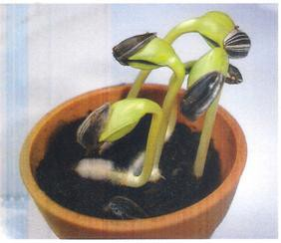

PLATE 5
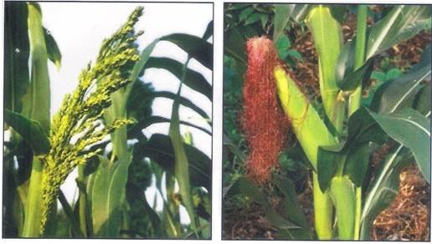

PLATE 6 PLATE 7
(i) The photograph in Plate 5 shows the germination process in a species of legume.
(a) (i) Name the type of germination shown in the photograph. (1 mark)
(ii) Give a reason for your answer. (1 mark)
(b) Other than germination the seedling has shown some responses.
(i) Name two responses shown in the photograph. (2 marks)
(ii) State one survival value of each of the response named above. (1 mark)

(ii) Examine the photograph in Plate 6 and Plate 7 which show different essential parts of a flower of a species on two different plants.
(a) Name the flower parts shown in Plate 6 and Plate 7. (2 marks)
(b) (i) Name the phenomenon described in the statement above. (1 mark)
(ii) Explain the significance of the phenomena stated in (a)(i) above. (1 mark)
(c) (i) State the mode of pollination of the flower shown in the photograph. (1 mark)
(ii) Give a reason for your answer. (1 mark)
. The diagrams below represent body parts of some organisms (animals). Study them and answer the question that follow.

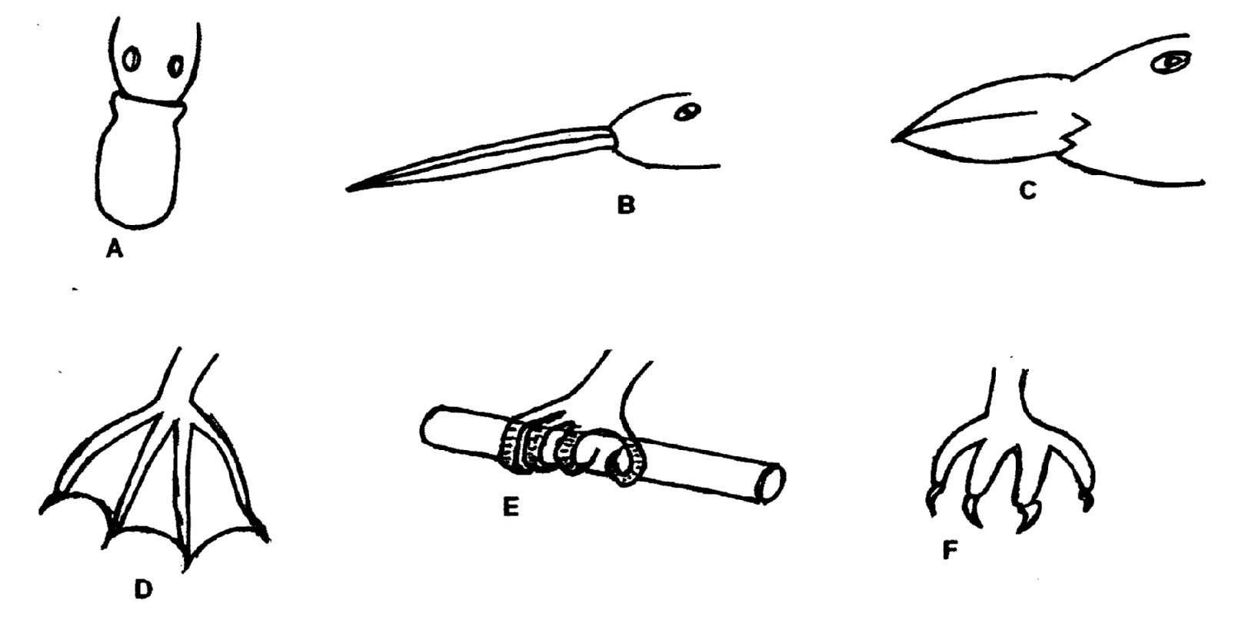

(a) i) Suggest the type of food eaten by organisms with the parts labeled A, B, C and F (4 mrks)
ii) With reasons, suggest the likely habitat of the organism from which the parts labeled D and E
were obtained. (4 mrks)
(b) (i) Suggest the type of evolution that is exemplified by the organisms labeled D, E and F. Give
reason for your answer. The type of evolution (2mks)
(ii) Suggest the significance of the above named type of evolution for the organism (2mks)

