NAME ADM NO CLASS
DATE SIGN
443/1
PAPER 1
TIME: 2 HOURS
MECS CLUSTER JOINT EXAMINATION
FORM FOUR END OF TERM TWO 2021
AGRICULTURE
PAPER ONE
TIME: 2 HOURS
INSTRUCTIONS TO CANDIADATES
- Write your name, admission number and class
- This paper contains three sections
- Answer all question in section A and B
- In section C answer any two questions
- Candidates should check the question paper to ascertain that all pages are printed as indicated and that no questions are missing
- This paper has 13 printed page
- Candidates must answer all the questions in English
For examiner’s use only
Section | Questions | Maximum score | Candidate score
A | 1 -15 | 30
B | 16-19 | 20
C |  | 20
 |  | 20
Total score |  | 90

SECTION A 30 MARKS
1. Name two physical agents of weathering (1 marks)
………………………………………………………………………………………………………………………………………………………………………………………………………………………………………………………………………………………………………………………………………………………………………………………………………………………………………………
2. Outline three methods of breaking seed dormancy (1 ½ marks)
…………………………………………………………………………………………………………………………………………………………………………………………………………………………………………………………………………………………………………………………………………………………………………………………………………………………………………………………
3. List two signs shown by crops when they are attacked by nematodes (1 marks)
…………………………………………………………………………………………………………………………………………………………………………………………………………………………………………………………………………………………………………………………………………………………………………………………………………………………………………………………
4. Distinguish between soil structure and soil texture (2 marks)
…………………………………………………………………………………………………………………………………………………………………………………………………………………………………………………………………………………………………………………………………………………………………………………………………………………………………………………………
5. State any three examples of working capital (1 ½ marks)
…………………………………………………………………………………………………………………………………………………………………………………………………………………………………………………………………………………………………………………………………………………………………………………………………………………………………………………………
6. What is Land reform: (1 mark)
……………………………………………………………………………………………………………………………………………………………………………………………………………………………………………………………………………………………………
(b) State any four methods of land reform (2 marks)
…………………………………………………………………………………………………………………………………………………………………………………………………………………………………………………………………………………………………………………………………………………………………………………………………………………………………………………………
7. Mention four ways in which losses may be incurred during hay making. (2marks)
……………………………………………………………………………………………………………………………………………………

……………………………………………………………………………………………………………………………………………………

……………………………………………………………………………………………………………………………………………………

………………………………………………………………………………………………………………………………………………
8. Give two precautions taken to ensure good crop establishment during planting. (1mark)

……………………………………………………………………………………………………………………………………………………………………………………………………………………………………………………………………………………………………
9.(a) Define inventory records. (1mark)
………………………………………………………………………………………………………………………………………………

………………………………………………………………………………………………………………………………………………
b). State four pieces of information that is contained in health records. (2marks)

………………………………………………………………………………………………………………………………………………

………………………………………………………………………………………………………………………………………………

………………………………………………………………………………………………………………………………………………

………………………………………………………………………………………………………………………………………………

10)a. List four problems associated with nomadic pastoralism in Kenya. (2marks)

………………………………………………………………………………………………………………………………………………

………………………………………………………………………………………………………………………………………………

………………………………………………………………………………………………………………………………………………

………………………………………………………………………………………………………………………………………………
(b) Name four factors of production in agriculture. (2marks)
……………………………………………………………………………………………………………………………………………………

……………………………………………………………………………………………………………………………………………………

………………………………………………………………………………………………………………………………………………

………………………………………………………………………………………………………………………………………………

11. List two farming practices that can be carried out to increase the amount of light harnessed by crops. (2marks)
……………………………………………………………………………………………………………………………………………………

………………………………………………………………………………………………………………………………………………

………………………………………………………………………………………………………………………………………………

………………………………………………………………………………………………………………………………………………

12 State four reasons why land is prepared before planting (2marks)
…………………………………………………………………………………………………………………………………………………………………………………………………………………………………………………………………………………………………………………………………………………………………………………………………………………………………………………………………………………………………………………………………………………………………………………………………………………………………………
13. Give one reason in each case why the following tertiary operations are important. (3marks)
  - Ridging
……………………………………………………………………………………………………………………………………………………………………………………………………………………………………………………………………………………………………………………
  - Rolling
……………………………………………………………………………………………………………………………………………………………………………………………………………………………………………………………………………………………………………………

  - Leveling
……………………………………………………………………………………………………………………………………………………………………………………………………………………………………………………………………………………………………………………
14. Distinguish the following terms as used in pasture management. (2marks)
  - Intensity of defoliation
……………………………………………………………………………………………………………………………………………………………………………………………………

  - Frequency of defoliation
……………………………………………………………………………………………………………………………………………………………………………………………………

15. What does the term ‘close season’ in crop production mean? (1mark)
……………………………………………………………………………………………………………………………………………………………………………………………………
SECTION B ANSWER ALL QUESTION
16. Use the following crops to answer the questions that follow.
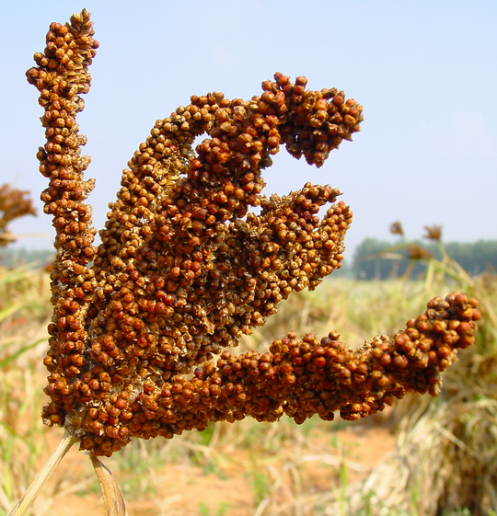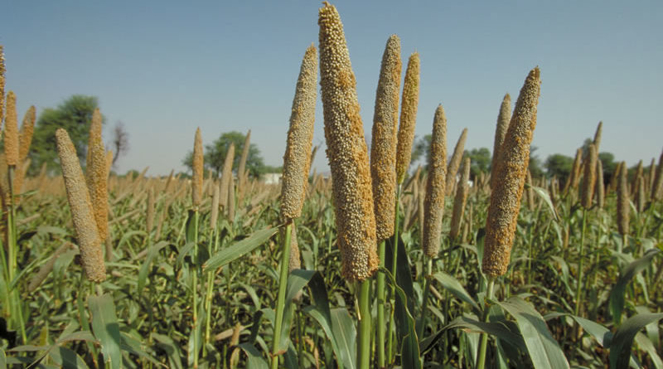
D E
- Name the crops labelled D and E above. (2mark)
D………………………………………………………………………………………...
E………………………………………………………………………………………...
- Why is crop D rarely destroyed by pests in the stores? (1mark)
………………………………………………………………………………………….
- Name any two diseases that affect crop E. (2marks)
…………………………………………………………………………………………………………………………………

17. The diagram F, below illustrates a method of training in crops.

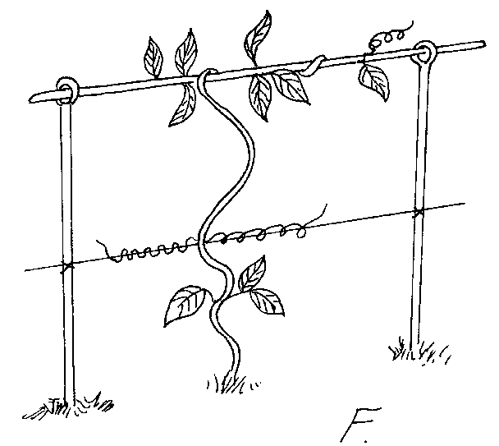

i) Identify the method shown in F above. (1mark)

………………………………………………………………………………………………

ii) Name two other methods used in training in crop production. (1mark)

………………………………………………………………………………………………

………………………………………………………………………………………………

iii) State two advantages of training in crop production. (2mark)
………………………………………………………………………………………………

………………………………………………………………………………………………

iv) List two crops that require training. (1mark)
………………………………………………………………………………………………

………………………………………………………………………………………………
18.a) Describe the procedure which should be followed in spraying a crop of tomatoes using a fungicide in powder form, water and knapsack sprayer. (3 marks)
………………………………………………………………………………………………………………………………………………………………………………………………………………………………………………………………………………………………………………………………………………………………………………………………………………………………………………………………………………………………………………………………………………………………………………………………………………………………………………………………………………………………………………………………………………………
(b) State two safety measures that should be taken while spraying the crop with fungicide (2 marks)
………………………………………………………………………………………………………………………………………………………………………………………………………………………………………………………………………………………………………………………………………………………………………………………………………………………………
19. The diagram below illustrate an experiment on soil
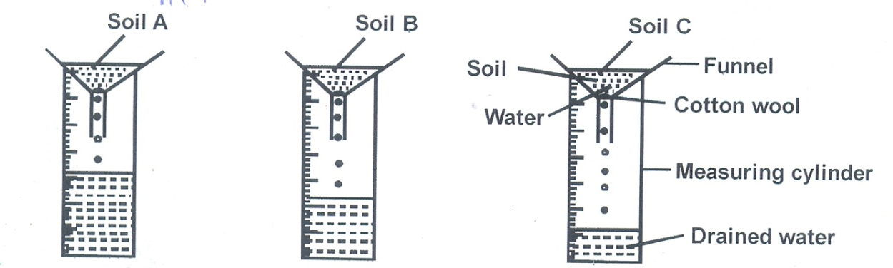
a) State the aim of the experiment (1 mark)
………………………………………………………………………………………………………
b) If the volume of water illustrated in the measuring cylinder was observed after one hour.
Identify the soil sample A and B
Soil A……………………………………………………………………………….. (1 mark)
Soil B………………………………………………………………………………… (1 mark)
c) State two ways in which the soil structure of the sample labelled c above can be improved. (2 marks)
…………………………………………………………………………………………………………………………………………………………

…………………………………………………………………………………………………………………………………………………………

…………………………………………………………………………………………………………………………………………………………

…………………………………………………………………………………………………………………………………………………………
SECTION C 40 MARKS
ANSWER ONLY TWO QUESTIONS
20. a) Giving one example in each case, identify three classes of crop diseases. (6marks)
b) Describe the physical measures of disease control in crops. (10marks)
c) Identify the factors affecting the efficiency of pesticides (4marks)

21).Describe the production of tomatoes (Lycoperiscon esculentum) under the following subheadings.
(a) Ecological requirements (4marks)
(b) Nursery establishment (4marks)
(c) Transplanting (4marks)
(d) Seed bed preparation (4marks)
(e) Field management practices (4marks)

22. a) State and explain five agricultural services available to farmers. (10marks)
b) Explain the ways in which labour efficiency can be increased in the farm (5marks)
c) State any five measures which are taken to minimize water pollution In the farm.
(5marks)

……………………………………………………………………………………………………………………………………………………………………………………………………………………………………………………………………………………………………………………………………………………………………………………………………………………………………………………………………………………………………………………………………………………………………………………………………………………………………………………………………………………………………………………………………………………………………………………………………………………………………………………………………………………………………………………………………………………………………………………………………………………………………………………………………………………………………………………………………………………………………………………………………………………………………………………………………………………………………………………………………………………………………………………………………………………………………………………………………………………………………………………………………………………………………………………………………………………………………………………………………………………………………………………………………………………………………………………………………………………………………………………………………………………………………………………………………………………………………………………………………………………………………………………………………………………………………………………………………………………………………………………………………………………………………………………………………………………………………………………………………………………………………………………………………………………………………………………………………………………………………………………………………………………………………………………………………………………………………………………………………………………………………………………………………………………………………………………………………………………………………………………………………………………………………………………………………………………………………………………………………………………………………………………………………………………………………………………………………………………………………………………………………………………………………………………………………………………………………………………………………………………………………………………………………………………………………………………………………………………………………………………………………………………………………………………………………………………………………………………………………………………………………………………………………………………………………………………………………………………………………………………………………………………………………………………………………………………………………………………………………………………………………………………………………………………………………………………………………………………………………………………………………………………………………………………………………………………………………………………………………………………………………………………………………………………………………………………………………………………………………………………………………………………………………………………………………………………………………………………………………………………………………………………………………………………………………………………………………………………………………………………………………………………………………………………………………………………………………………………………………………………………………………………………………………………………………………………………………………………………………………………………………………………………………………………………………………………………………………………………………………………………………………………………………………………………………………………………………………………………………………………………………………………………………………………………………………………………………………………………………………………………………………………………………………………………………………………………………………………………………………………………………………………………………………………………………………………………………………………………………………………………………………………………………………………………………………………………………………………………………………………………………………………………………………………………………………………………………………………………………………………………………………………………………………………………………………………………………………………………………………………………………………………………………………………………………………………………………………………………………………………………………………………………………………………………………………………………………………………………………………………………………………………………………………………………………………………………………………………………………………………………………………………………………………………………………………………………………………………………………………………………………………………………………………………………………………………………………………………………………………………………………………………………………………………………………………………………………………………………………………………………………………………………………………………………………………………………………………………………………………………………………………………………………………………………………………………………………………………………………………………………………………………………………………………………………………………………………………………………………………………………………………………………………………………………………………………………………………………………………………………………………………………………………………………………………………………………………………………………………………………………………………………………………………………………………………………………………………………………………………………………………………………………………………………………………………………………………………………………………………………………………………………………………………………………………………………………………………………………………………………………………………………………………………………………………………………………………………………………………………………………………………………………………………………………………………………………………………………………………………………………………………………………………………………………………………………………………………………………………………………………………………………………………………………………………………………………………………………………………………………………………………………………………………………………………………………………………………………………………………………………………………………………………………………………………………………………………………………………………………………………………………………………………………………………………………………………………………………………………………………………………………………………………………………………………………………………………………………………………………………………………………………………………………………………………………………………………………………………………………………………………………………………………………………………………………………………………………………………………………………………………………………………………………………………………………………………………………………………………………………………………………………………………………………………………………………………………………………………………………………………………………………………………………………………………………………………………………………………………………………………………………………………………………………………………………………………………………………………………………………………………………………………………………………………………………………………………………………………………………………………………………………………………………………………………………………………………………………………………………………………………………………………………………………………………………………………………………………………………………………………………………………………………………………………………………………………………………………………………………………………………………………………………………………………………………………………………………………………………………………………………………………………………………………………………………………………………………………………………………………………………………………………………………………………………………………………………………………………………………………………………………………………………………………………………………………………………………………………………………………………………………………………………………………………………………………………………………………………………………………………………………………………………………………………………………………………………………………………………………………………………………………………………………………………………………………………………………………………………………………………………………………………………………………………………………………………………………………………………………………………………………………………………………………………………………………………………………………………………………………………………………………………………………………………………………………………………………………………………………………………………………………………………………………………………………………………………………………………………………………………………………………………………………………………………………………………………………………………………………………………………………………………………………………………………………………………………………………………………………………………………………………………………………………………………………………………………………………………………………………………………………………………………………………………………………………………………………………………………………………………………………………………………………………………………………………………………………………………………………………………………………………………………………………………………………………………………………………………………………………………………………………………………………………………………………………………………………………………………………………………………………………………………………………………………………………………………………………………………………………………………………………………………………………………………………………………………………………………………………………………………………………………………………………………………………………………………………………………………………………………………………………………………………………………………………………………………………………………………………………………………………………………………………………………………………………………………………………………………………………………………………………………………………………………………………………………………………………………………………………………………………………………………………………………………………………………………………………………………………………………………………………………………………………………………………………………………………………………………………………………………………………………………………………………………………………………………………………………………………………………………………………………………………………………....

