Name……………………………………………….Adm no………Class…
Index No……………………….. Signature…………………………

121/2
Mathematics Paper 2
Form 4
2 ½ Hours
End of Term 1 –September 2021
KASSU JET EXAMINATIONS 2021
Kenya Certificate of Secondary Education (K.C.S.E)
INSTRUCTIONS TO CANDIDATES
- Write your name and Admission number in the spaces provided at the top of this page.
  - This paper consists of two sections: Section I and Section II.
  - Answer ALL questions from section I and ANY FIVE from section II
  - All answers and workings must be written on the question paper in the spaces provided
below each question.
  - Show all the steps in your calculation, giving your answer at each stage in the spaces
below each question.
  - Non – Programmable silent electronic calculators and KNEC mathematical tables may be
used, except where stated otherwise.

FOR EXAMINERS USE ONLY

SECTION I

1 | 2 | 3 | 4 | 5 | 6 | 7 | 8 | 9 | 10 | 11 | 12 | 13 | 14 | 15 | 16 | TOTAL

SECTION II

17 | 18 | 19 | 20 | 21 | 22 | 23 | 24 | TOTAL

GRAND TOTAL
SECTION I (Answer ALL the questions in this section)

- Migwambo and Abraham can do a piece of work together in 15 days. Abraham working alone can do the same piece of work in 20 days. How long will Migwambo working alone take to do the same work? (3 marks)

- Given the measurements P=12.5cm, Q=5.0cm and R=2.5cm, find in 4significant figures, the percentage error in $\frac{P}{QR}$ (3 marks)

- Make $b$ the subject of the formula in $S=\frac{\sqrt{3t(b-x)}}{9}$ (3 marks)

- Solve for $x$ given M= $\left(\begin{matrix}-2 & -3x \\ x & 6\end{matrix}\right)$ is a singular matrix hence state the possible matrices (3 marks)

- Find the exact value for x in the following equation $\log_{2}{(x+4)}=2-\log_{2}{\frac{1}{8}}$
(3 marks)

- Solve by completing the square: (3 marks)
2$\frac{1}{2}x^{2} + 1\frac{2}{3} x -1\frac{1}{4}$ = 0.

- The cash price of a Samsung S20 is Ksh. 125,000. Yianti bought the phone on hire purchase terms by paying a deposit of Ksh. 70,000 and the balance by 24 equal monthly instalments of Ksh. 3,000. Find the rate of carrying charge per year giving your answer to 4 significant figures. ( 3marks)

- An arc length of 18.5 cm subtends an of angle of 1.2^{c} at the centre of the circle .Find the diameter of the circle to one decimal place. (4 marks)

- Solve for $α$ in the equation 3Cos 5α⁰= $-\frac{3\sqrt{2}}{2}$ where $0^{0}≤α≤{100}^{0}$ (3 marks)

- John spent one-third of his money on bread and two-fifths of the remainder on soda. He used the balance to purchase four pens at a total cost of sh. 300.How much money did he have at the beginning? (2 marks)

- 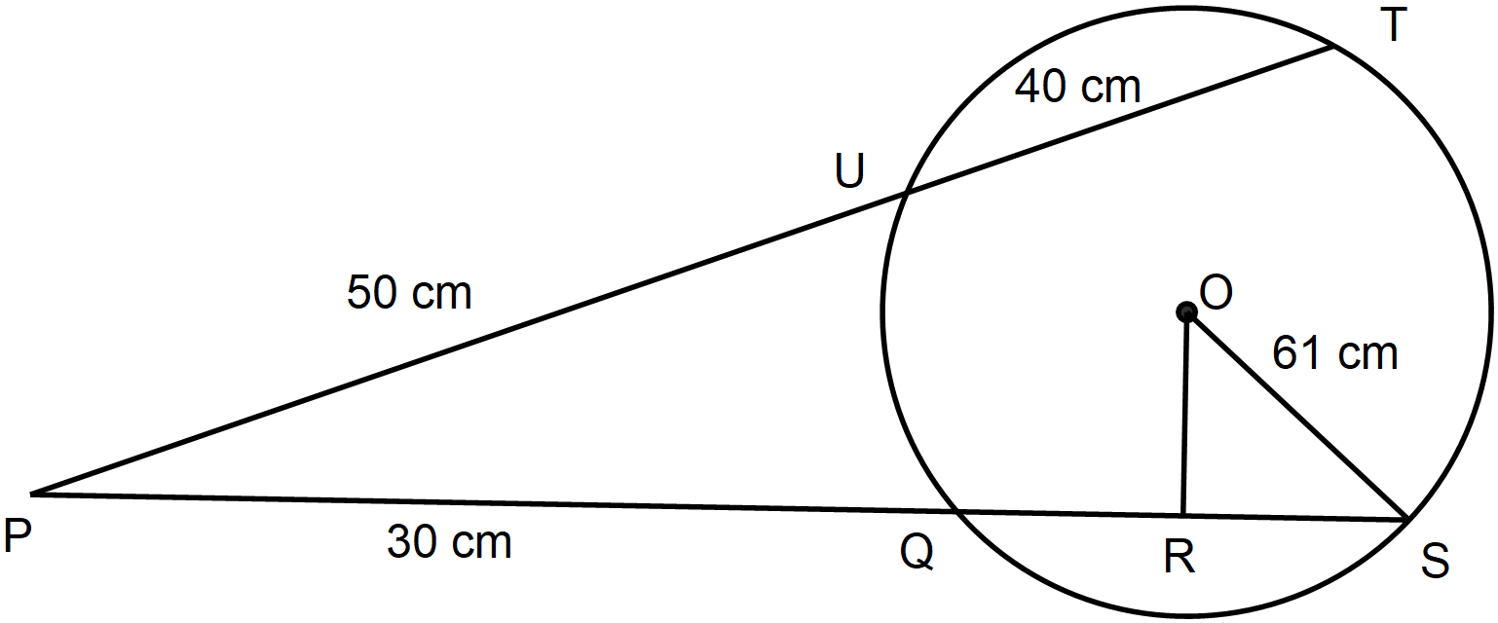In the figure below OS is the radius of a circle centre O. Chords SQ and TU are extended to meet at P and OR is perpendicular to QS at R. OS = 61 cm, PU = 50 cm, UT = 40 and PQ = 30 cm.

Calculate the length of
- QS (2 marks)

- OR to 2 decimal places (1 mark)

- Expand ( 1+x) up to the term in x in ascending powers of x .Hence find the value of (1.005) correct to four decimal places. (4 marks)

- The charge, C shillings per person for a certain seminar is partly fixed and partly varies inversely as the total number of N people. Given that when 100 people attend the charge is ksh 8,700 per person while when 35 people attend the charge per person increases by ksh 1300. Calculate the fixed charge. (3 marks)

- Without using a calculator or mathematical table evaluate $\frac{2tan{60}^{0}}{sin{45}^{0}-cos{30}^{0}}$ leaving your answer in simplified form. (3 marks)

- Use logarithms to evaluate; (3 marks)
$\sqrt[4]{\frac{log6 × 27.5}{0.46 × 36}}$.

- The equation of a circle is x² + y² + 6x – 10y – 2 = 0. Determine the co-ordinates of the centre and the area of the circle in terms of π (3 marks)

SECTION II (Answer ONLY 5 questions in this section)
- (a). Complete the table below for the function $y=\left(x+3\right)\left(x+1\right)(x-2)$ (2 marks)
x | $$-4$$ | $$-3$$ | $$-2$$ | $$-1$$ | 0 | 1 | 2 | 3
y |  |  |  |  | $$-6$$
(b). Using the values obtained in the table above draw the graph of $y=\left(x+3\right)\left(x+1\right)(x-2)$. (3 marks)
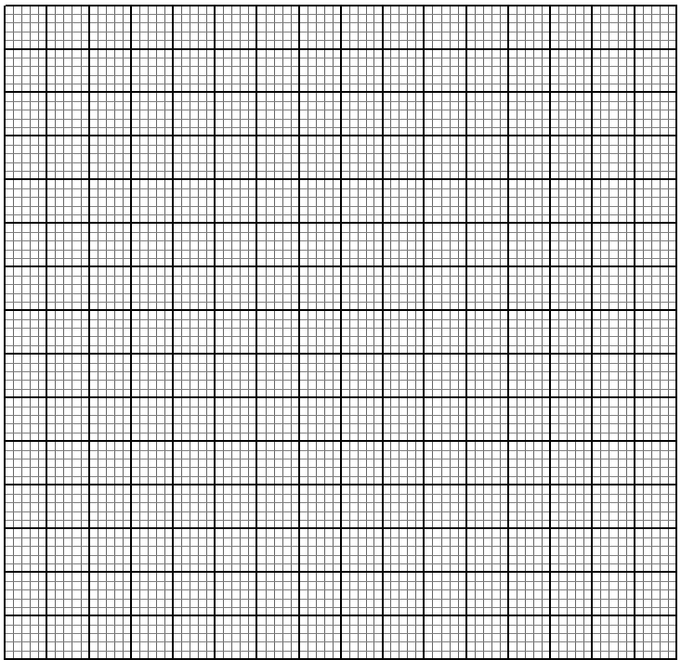
- Using your in (b) above, solve the following equations.
- $x^{3}+{2x}^{2}-5x-6=0$ (2 marks)

- $x\left(x^{2}+2x-4\right)=8$ (3 marks)

- a) Given the series 2 + 4 + 8 + 16 +----------+ 16384,
- Identify the type of series (1 mark)

- Find the number of terms in the series (3 marks)

- Calculate the sum terms in the series (3 marks)

b) The first three consecutive terms of an increasing geometric progression are 3 , x, and 5$\frac{1}{3}$ . Find the value of x. (3 marks)

19. Construct triangle ABC in which $AB = 5.4 cm$, $BC = 7.4 cm$ and $AC = 8.4 cm.$ Construct an escribed circle opposite angle ACB (5 marks)

(a) Measure the radius of the circle (1 mark)

(b) Measure the acute angle subtended at the centre of the circle by AB (1 mark)

(c). Calculate the area of triangle OBA with O as the centre of the circle (3 marks)

20. A triangle OPQ is such that $OP=p$ and $OQ = q$. A point R divides OP in the ratio 1:2 and a point S divides PQ in the ratio 5:2. OS and RQ meet at T.
- Express in terms p and q
- OS (1 mark)

- QR (1 mark)

- Given that OT=hOS and RT= kRQ, express OT in terms of
- $h,p$ and $q$ (1 mark)

- $k,p$ and $q$ (1 mark)

- Find the values of $h$ and $k$ (4 marks)

- Find the ratio in which R divides line QT (2 marks)

21. The figure below shows two intersecting circles with centres A and B and radii 12cm and 10cm respectively. CD = 8cm and is a common chord. Calculate to one decimal place
- the area of quadrilateral ACBD (3 marks)
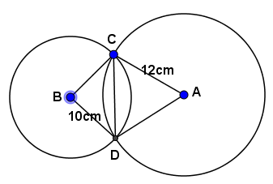

- the area of the common region between the intersecting circles. Use π=$\frac{22}{7}$
(5 marks)

- the area in quadrilateral ACBD that is not shared by the intersecting circles. (2 marks)

22. The probability of Patrick passing his exam is 0.8 that of James is 0.6 while that of Lewis is 0.2.
(a) Draw a tree diagram to represent the above information (2 marks)

(b) Use your tree diagram to find the probability that;
- Exactly two students pass in the exam (2 marks)

- At most two students pass the exam (2 marks)

- Only one student passes the exam (2 marks)

- At least one passes in the exam (2 marks)

23. (a) Triangle ABC with vertices $A(1,1),$ $B(4,4)$ and $C(3,2)$ is mapped onto triangle A^{I}B^{I}C^{I} by transformation represented P = $\left(\begin{matrix}-1 & 0 \\ 0 & -1\end{matrix}\right)$. State the coordinates of A^{I}B^{I}C^{I} hence plot the triangle and its image on the grid provided below. (3 marks)

(b). A^{II}B^{II}C^{II} is the image of A^{I}B^{I}C^{I} under transformation represented by T= $\left(\begin{matrix}2 & 0 \\ 0 & 2\end{matrix}\right)$. State the coordinates of A^{II}B^{II}C^{II} hence plot the triangle on the same grid. (2 marks)

(c) A^{II}B^{II}C^{II} is mapped onto A^{III}B^{III}C^{III} by a reflection in the line $y=x$. Plot A^{III}B^{III}C^{III} and hence state the coordinates (2 marks)

(d) Find the matrix that represents the transformation that maps triangle A^{III}B^{III}C^{III} onto ABC.
(3 marks)

24. The table below shows marks scored by students in a given test
Marks | frequency
70 – 74 | 4
75 – 79 | 8
80 – 84 | 11
85 – 89 | 15
90 – 94 | 9
- – 99 | 3

(a). Using an assumed mean of 87, Estimate;
- The mean (3 marks)

- The standard deviation (4 marks)

(b). Calculate the 5th decile (3 marks)

