LANJET CLUSTER EXAMINATION
GEOGRAPHY Paper 1 (312/1).
DECEMBER, 2021
MARKING SCHEME

SECTION A
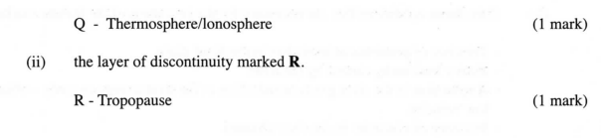
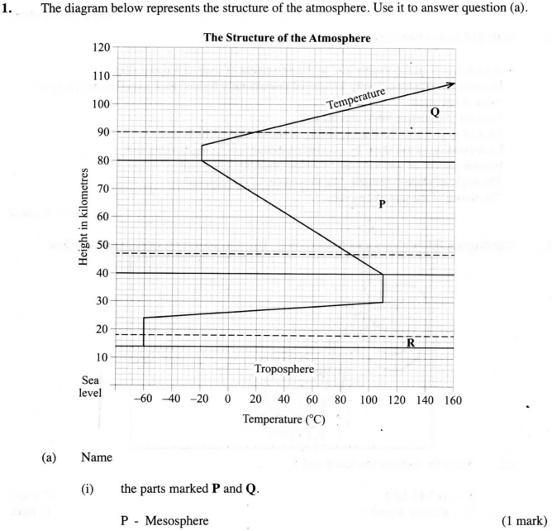

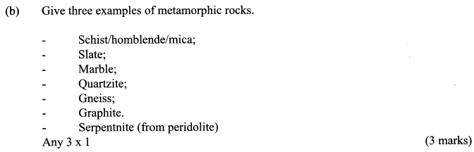
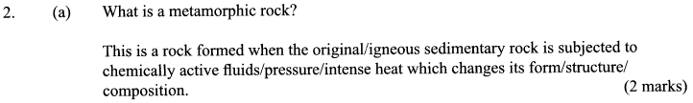

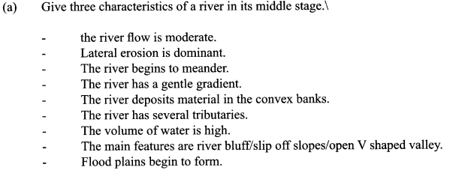
3.

- a)Identify the main characteristics of the ocean water
- Ocean water is saline/salty.
-The temperature of ocean water varies horizontally and vertically.
-Varies in density
-It is in constant movement
b)Give the factors that influence wave deposition
- The depth of the water should be shallow along the coast
-Configuration of the coastline/change in the alignment of coastline
-The shore should have a gentle gradient
-The breaking waves should have strong swash and a weak backwash./ constructive waves
-Ample materials to be deposited
- a)Name three features that make up the hydrosphere
- Oceans
- Seas
- Lakes
- Rivers
- Swamps
- Ice sheets

b) Explain how the movement of magma causes earth movement.
- The molten rocks (magma) is forced to intrude into the earth’s crust through a line of weakness causing displacement
- The crustal rocks are forced to move/give way to intruding magma as their place is taken over by the intruding magma.
- Study the map of Kijabe 1:50,000 provided and answer the following questions:

(i) What is the appropriate height of the top of Kijabe hill?
- Between 2660 and 2680 above sea level

​(ii) Measure the length of Nairobi – Naivasha railway line from landhies (grid reference 257978) to the level crossing near Kijabe station ( grid reference 308984). Give your answer in kilometers.
- 5.6 km (0.1) (5.5 – 5.7 Km)

​(iii) What relief feature on the map may have created problems in the construction of the railway line?
- Escarpment steep slopes / Kijabe hill

​(b) Describe the drainage of the area covered by the map
- The main drainage feature are rivers, and are many
- There are also hot springs
- Most of the rivers are permanent
- Rivers originating from Kijabe hill are short and disappear underground
- Rivers on Kijabe hill form parallel and radial drainage pattern
- Most rivers from dendrite patter
- Main rivers are upper Ewaso Kedong and Bathi which flow southwards while river Gatamaiyu and its tributaries flow South – Eastwards
- Most rivers are in Their youthful stage
- There are more rivers to the East of the escarpment

​(c) Explain how relief has influenced the distribution of settlement in the area covered by the map.
- Most of the settlement are found at the foot of the escarpment because the land is gently sloping
- The escarpment has no settlement because the land is steep
- Kijabe hill has a few settlement on the eastern side because the land is gently slopping/ the Western side of the hill has no settlement as the land is steep
- The land immediate to the east of the escarpment has many settlement because it is plateau/ gently sloping

​(d) Citing evidence from the map, state four economic activities carried out in the area covered by the map.
Economic activities -Evidence
- Forestry / raw industry/ lumbering - Forest station/ forest guard post/ saw mills
- Cattle keeping/ livestock rearing / dairy - Dairy/ cattle dip
- Quarrying - Qua murram pit
- Transportation - Road/ Railway/ Tracks/ foot path
- Trading/ commerce - Shops/ stores/ petrol station/ post office/ post house
- Processing/ manufacturing - Kagwe carbacid plant
- Farming/ Agriculture – Plantations

​(e) Suppose you were a student in the school at Kinari ( Kinale) and you plan to carry out a field study of Wakagwe forest,
(i) Design a working programme (schedule) you would use during the day of the study

- Assemble equipment
- Depart for the area of study
- Arrive at the area of study
- Report to the forest authorities
- Embark on data collection
- Report back to the forest authorities
- Report back to school

​(ii) Give three reasons why it would be necessary to sample part of the forest for the study
- Save on time
- Save on energy
- Teach the learners the art of swimming
- They will be able to identify the tree species that are suitable for the area
- They will be able to work out solutions to the problems affecting the forest

​(iii) State two ways in which your findings would be useful to the local community.
- The community will use the report to identify the importance of conserving forests
- People will be able to adopt appropriate methods of utilizing the forest sustainable

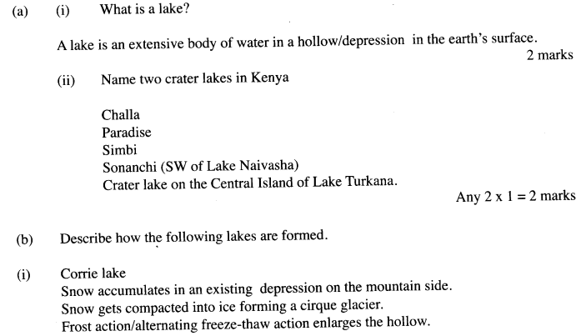

- a)(i) Name three types of faults. (3 marks)
- Normal fault
- Reverse fault
- Tear or shear or slip or transform or wrench or slip fault
- Thrust fault
- Anticlinal fault

b)(ii) Apart from compressional forces, explain two other process that cause faulting. (4 marks)
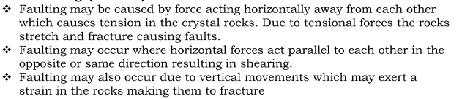
(d) (i) Methods of collecting data:
-observation
-taking photograph
-collecting samples
-taking measurements
(ii) Features likely to be observed in faulted area:
- fault scarps
- block mountains /horst/fault block
- tilt blocks
- fault steps
- rift valley

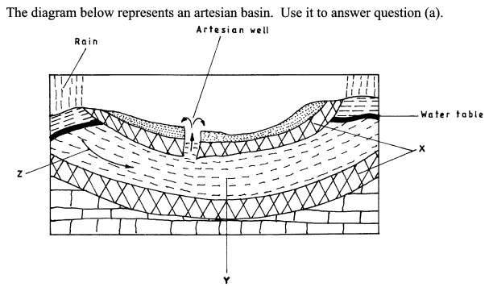

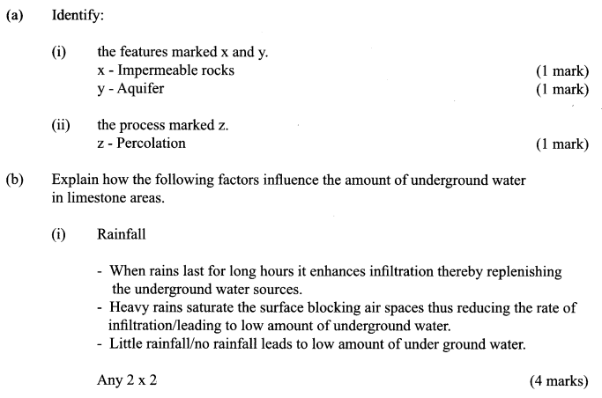
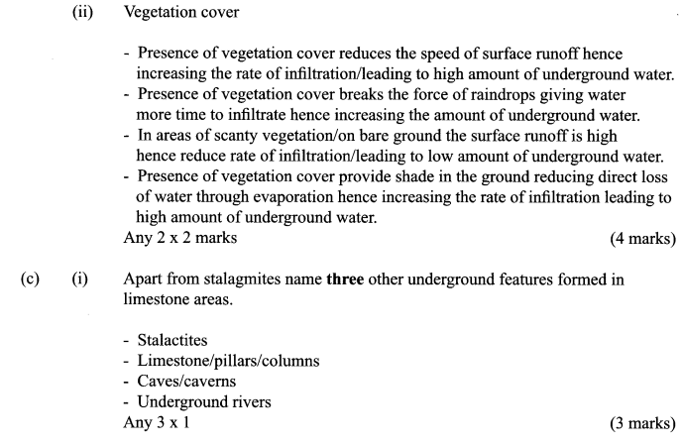

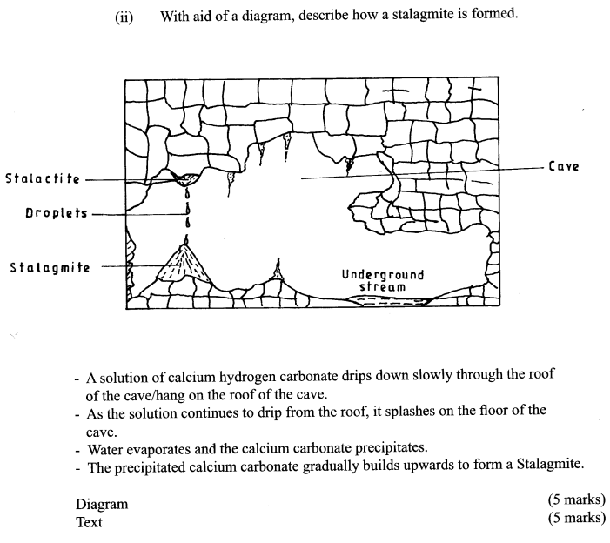

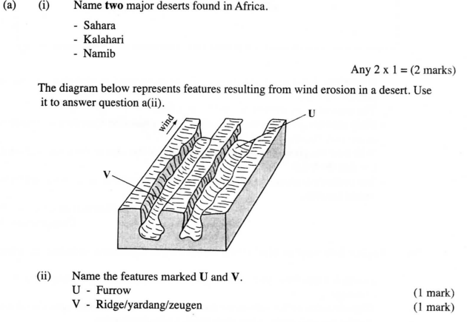

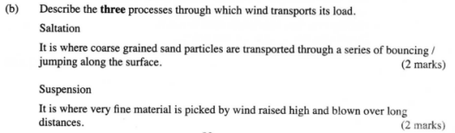

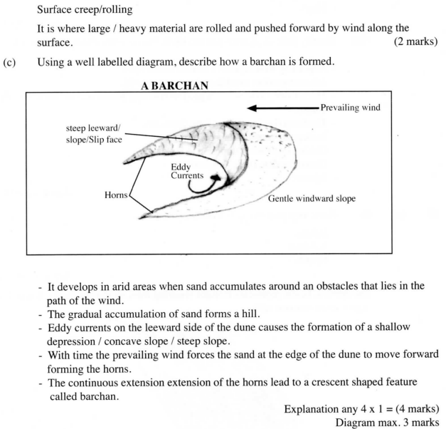
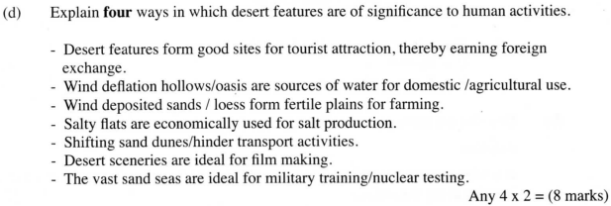

(e) (i) Drainage feature in arid area:
- Oasis
-Playa
(ii) Problems likely to be encountered:
- Accidents
- Attack by wild animals
- Lack of water
- Lack of food
- Fatigue
- Some areas may not be accessible.

