NAME:……………………………………… INDEX NO. ……………..…….…

SIGNATURE: ………………….... ……….. DATE: ...........................................

121/1
MATHEMATICS
PAPER 1
DECEMBER, 2021
TIME: 2 ½ HOURS

LANJET JOINT EVALUATION TEST 2021
Kenya Certificate of Secondary Education (K.C.S.E)
MARKING SCHEME

INSTRUCTIONS TO CANDIDATES
- Write your name and Admission number in the spaces provided at the top of this page.
- This paper consists of two sections: Section I and Section II.
- Answer ALL questions in section 1 and ONLY FIVE questions from section II
- All answers and workings must be written on the question paper in the spaces provided below each question.
- Show all the steps in your calculation, giving your answer at each stage in the spaces below each question.
- Non – Programmable silent electronic calculators and KNEC mathematical tables may be used, except where stated otherwise.

FOR EXAMINERS USE ONLY
SECTION I
1 | 2 | 3 | 4 | 5 | 6 | 7 | 8 | 9 | 10 | 11 | 12 | 13 | 14 | 15 | 16 | TOTAL
SECTION II GRAND TOTAL

17 | 18 | 19 | 20 | 21 | 22 | 23 | 24 | TOTAL

- Evaluate without using tables or calculators (2mks)
⁶/₇ of ¹⁴/₃ ÷ 80 x ⁻²⁰/₃
-2 x 5 ÷ (14 ÷ 7 ) x 3
⁶/₇ x ¹⁴/₃ = 4
4 ÷ 80 = ⁴/₈₀
⁴/₈₀ x = ²⁰/₃=⁻¹/₃
-2 x5 ÷ 2 x 3
-2 x ⁵/₂ x 3
-15
-¹/₃
-15
-¹/₃÷-¹⁵/₁ M1 – num/den
⁻¹/₃ x ¹/₄₅ M1 – single fraction
=1/₄₅ A1
3

- The line y = 3x + 3 meets the line L1 at the point (2, 9) and at right angles. Find the points at which the two lines intersect with the x- axis. (3mks)
G1=3 3y= -x +29 for L2
G2=⁻¹/₃ y= ⁻¹/₃ x + ²⁹/₃ 0= ⁻¹/₃x + ²⁹/₃
Equation L2 at x –axis, y=0 ¹/₃x=²⁹/₃
y-9 = -1 4 0= 3x + 3 x = 29 M1- gradient
x-2 3 3x = -3 (29,0) M1 – Equations a+y=0
3y – 27 = -x +2 x = 11 A1- both intercepts
( -1, 0) 3
- Given that p=5a – 2b where a = 3 and b = 4 , find :
2 1
- Column vector p. (2mks)
P = 5 3 - 2 4
2 1

= 15 - 8
10 2

P = 3 M1- substitution
8 A1 - p
2

- P΄ the image of p under a translation vector -6 (1mk)
4
P΄ = P + T
= 3 + -6 B1
8 4

= -3
12
- Solve the following inequalities and represent the solution on a number line. (3mks)
4x – 3 ≤ 6x -1 < 3x + 8

- Ux – 3 ≤6x – 1
-2x ≤ 2 M1- both solutions
x≥-1 B1- compound statement
- 6x -1<3x+8 B1- correct number line
3x<9 3
X<3

-1≤x<3

-2 -1 0 1 2 3 4

- The figure below shows a triangular prism of uniform cross section. AF=FB= 4cm. AB=7cm, BC= 12cm. given that angle BAF=30º, find the total surface area of the prism. (3mks)
C
F
A
B
D
E

4cm
120^{O}
30^{O}
4cm
7cm
12cm

30^{O}

Area of Δ faces = ½ x 4x 4 x sin120x2 M1- cross sector faces
= 13.856 M1- other faces
= 14cm² A1- Area got
Area of rectangles = 12 x 4x2+12x6 3
= 96+72
=168
Total S.A =168+13.856
= 181.856 accept 182cm²
= 181.9cm²
Alternative
h=√4² - 35²
=√16-12.25
=1.94cm
Area of triangular
Faces = ½ x 1.94 x 7x2
=13.587cm²
Total = 168+13.587
=181.58 = 181.6cm²

- Use tables of cubes, cube roots and reciprocals to evaluate: (4mks)

23.5³- 3 4411 + 1
0.0071

(2.35 x 10¹)³ - 3√4.411 x 10³+ 1
7.1 x 10⁻³ M1-all logs
12.978 x 10³ – 1.64 x 10 + 0.1408 x 10³ M1 – addition & subtraction
12,978 – 16.4 + 140.8 = 13,102.4 M1- multiplication
A1
4

- The density of a substance A is given as 13.6g/cm³ and that of a substance B as 11.3g/cm³. Determine, correct to one decimal place, the volume of B that would have the same mass as 50cm³ of A. (3mks)
D = ^{m}/_{v}
Mass of A = 50cm³ x 13.6g/cm=³680g
Mass of B = 680g M1-masses got
Density = 11.3g/cm³ M1- vol. expressed
Volume of B = 680g A1
11.3g/cm³ 3
= 60.2cm³
- Find x in 2(4^{x}) – 10 (2^{x}) + 8 = 0 (3mks)
4^{x}-5(2^{x}) + 4 =0 u²- 4u – u + 4 = 0 also:
(2²)^{x} – 5 (2^{x})+4 = 0 u(u – 4) -1 (u – 4) = 0 2^{x}=4=2² M1- common base
Let 2x be u (u – 1 ) (u – 4) = 0 x =2 M1-quadratic eqn
U² – 5u + 4 =0 u = 1 or 4 x =0 A1- both
(-4, -1) 2^{x}= 1 = 2^{O} and 3
X = 0 2

- The sum of interior angles of a regular polygon is 24 times the size of the exterior angle.
Find the number of sides of the polygon. (3mks)
- (2n – 4) 90= 24 x ³⁶⁰/_{n}
180n – 360 = 8640
n
- 180n² – 360n = 8640
n² – 2n – 48 =0
-48 = -8 x 6
-2 = -8+6
(n – 8) (n + 6) = 0
n=8 M1-equating
Or M1 – single equation
-6 A1
8 sides 3
- Triangle ABC has its vertices at A(3, 0), B(2,3) and C(5,1) if A΄(5, 0), B΄(3,6) and C΄(9,2) is the image of ABC under enlargement. On the same axes and grid provided below, determine the centre of enlargement and linear scale factor. (3mks)

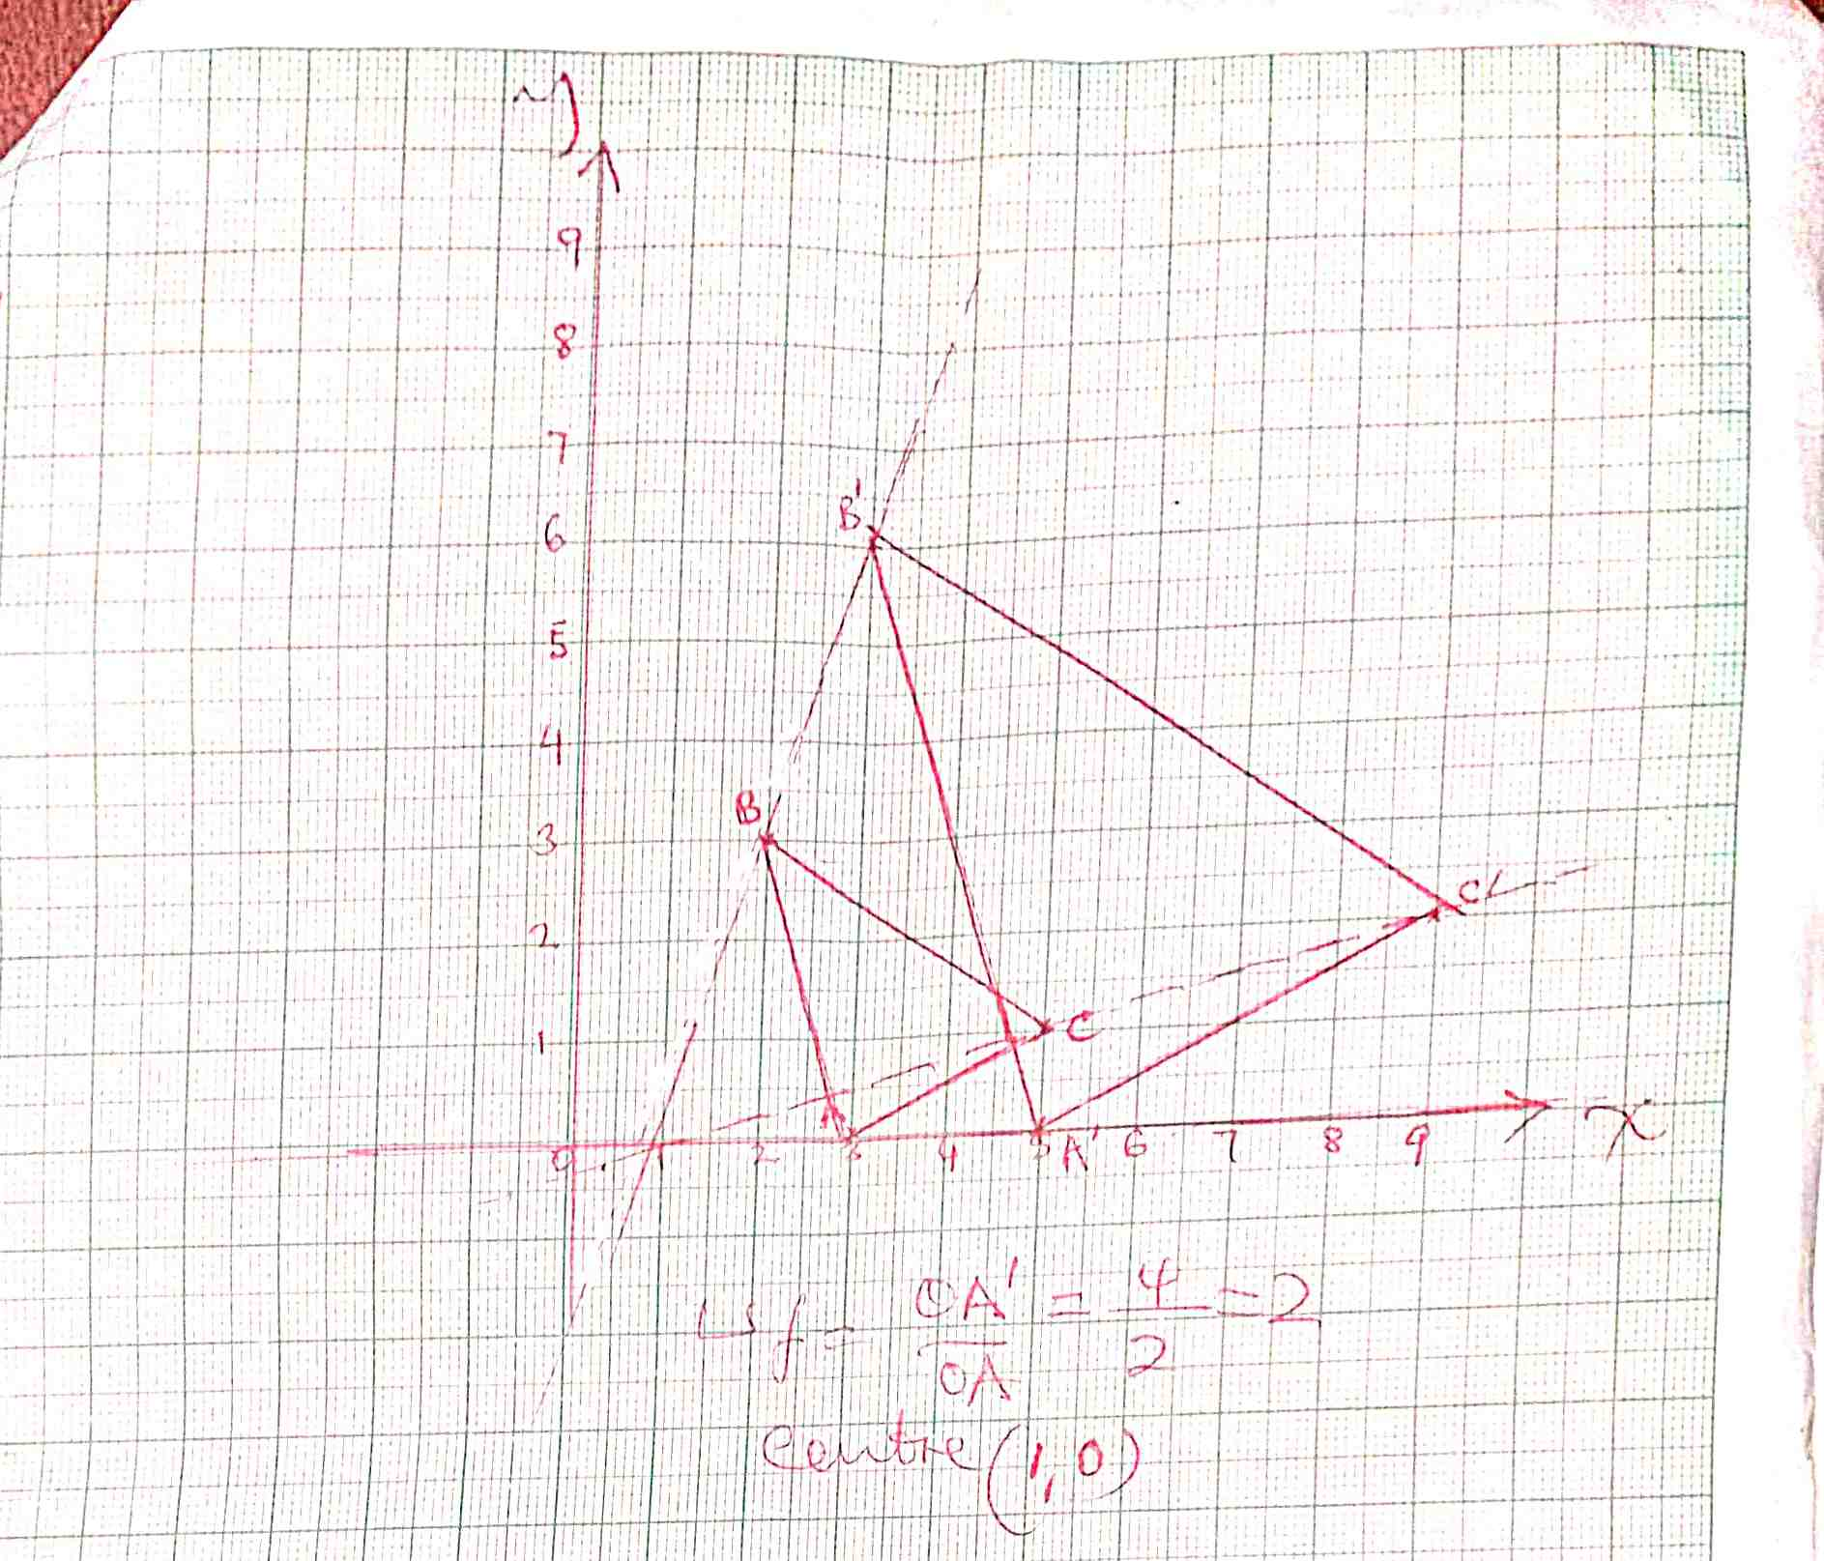

B1-Both Ds drawn
B1-centre identified
B1-LSF
3

- The following measurements were recorded in a field book of a farm using XY as the base line XY=400M.
Y
C 60 1.5cm 340 8.5cm 3cm
300 7.5cm 120 D
240 6cm 100 E 2.5cm
2.5cm 220 5.5cm 160 F 4cm
B 100 140 3.5cm
A 120 80 2cm
3cm

X

Using a suitable scale, draw an accurate map of the farm. (4mks)

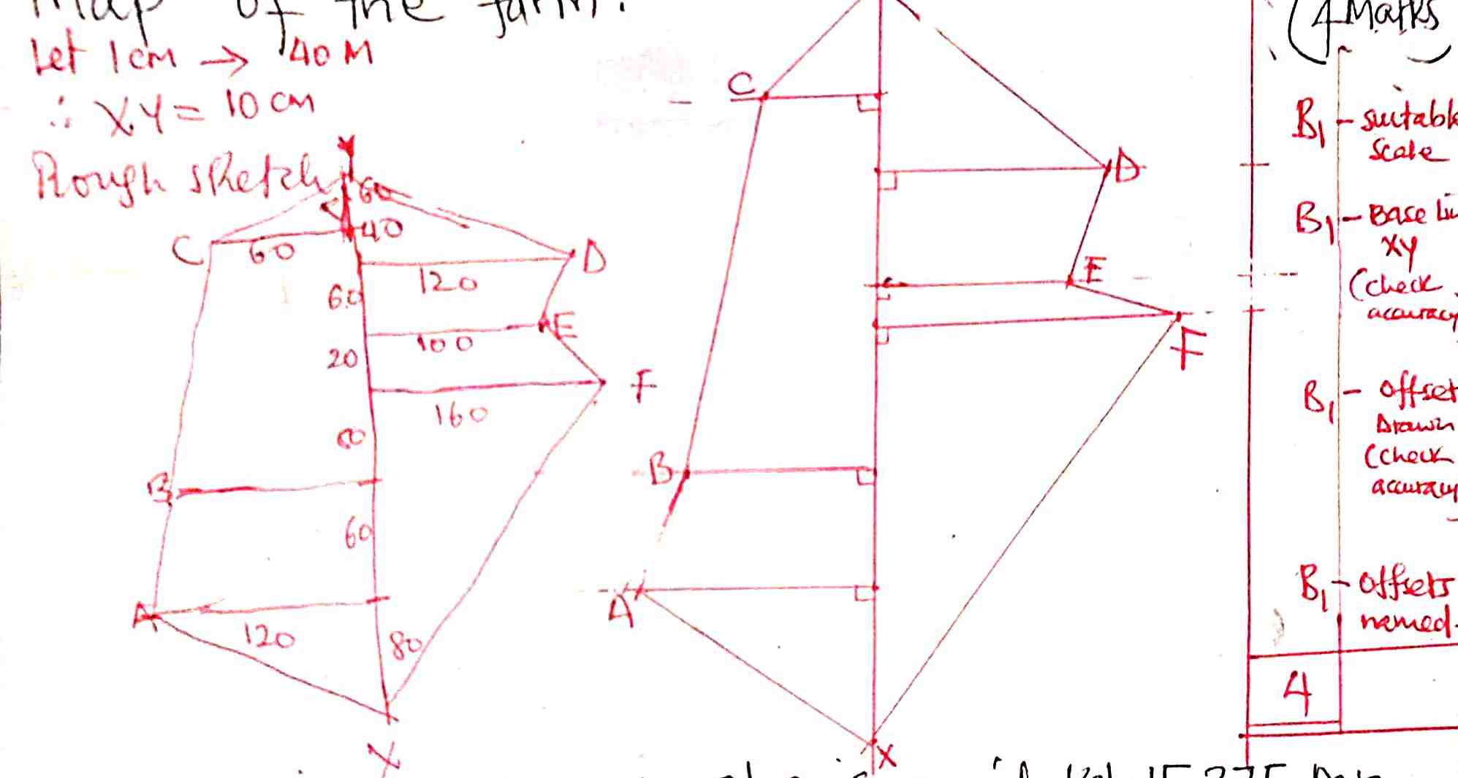

B1-suitable scale
B1-base line xy(Check accuracy
B1-offsets drawn(check accuracy)
B1-offsets named
4

- Waceke is a saleslady. She is paid Ksh 15,375 per month. She is also paid a commission of 4 ½ % on the amount of money she makes from her sales. In a certain month, she earned a total of Ksh. 28,875. Calculate the value of her sales that month. (3mks)
Earnings on sales = 28875 – 15375
= sh 13,500
4 ½ % of y = 13500
M1-sales on earnings
Y= 100 x 13500 M1-eqation
4.5 A1-for sales
Y = sh 300,000 3

- Two buses P and Q leave Kisumu at 7.30am and 9.30am respectively. If their speeds are 60km/h and 100km/h respectively, find when Q catches up with P. (3mks)
Distance by p in 2hrs alternative method y= 180km
60 x 2 = 120km y 120 time= 180 =3hrs
RS= 100-60 60
= 40Km/hr distance by P = y km time to catch
Time to overtake time = (^{y}/₆₀)hrs up = 9.30 + 3
= 120 = 3hrs distance by Q = 120 + y = 12.30p.m
40 time = 120 + y
9.30 +3hrs 100
12.30p.m 100y = 7200 + 60y M1-RS/RD
40y = 7200 M1-1-time add
A1-
3

- The figure below shows a solid cone. It has a cylindrical hole drilled into it. The diameter of the hole is 7cm and its height 8cm. The radius of the cone is 10.5cm and its vertical height is 15cm.

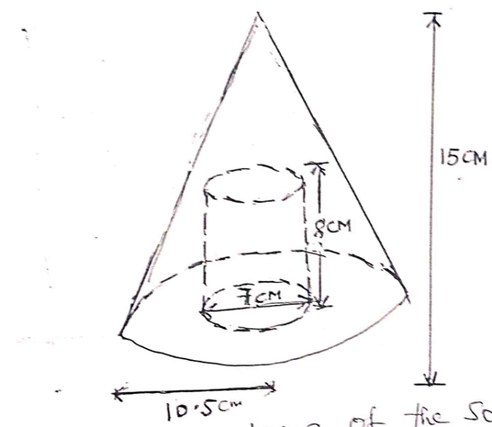

Calculate the volume of the solid. (3mks)
Volume of the cone – volume of cylinder M1-values subst in formula
¹/₃ πR²H – πr²h M1-simplifying
π(¹/₃ x 10.5² x 15 – 3.5²x8) A1
π(551.25 – 98) 3
453.25π
=1424.5cm³

- Simplify completely: (3mks)
(a +2b)² – ( 2a – b)²
ab² – a²
let a + 2b =x (3a +b) (3b –a)
2a – b = y (3b +a) (3b-a)
x²-y²= (x + y) (x-y) 3a+b
(a+2b+2a-b) (a+2b-(2a-b)) 3b+a
(3a+b) (-a+3b)
(3a+b) (3b-a) M1-factors expressed in num/den
(3b)² –a² M1-single fraction
(3b+a)(3b-a) A1
3

- The figure below represents a speed time graph for a cheetah in 40 seconds.
Calculate the total distance covered by the cheetah. (3mks)

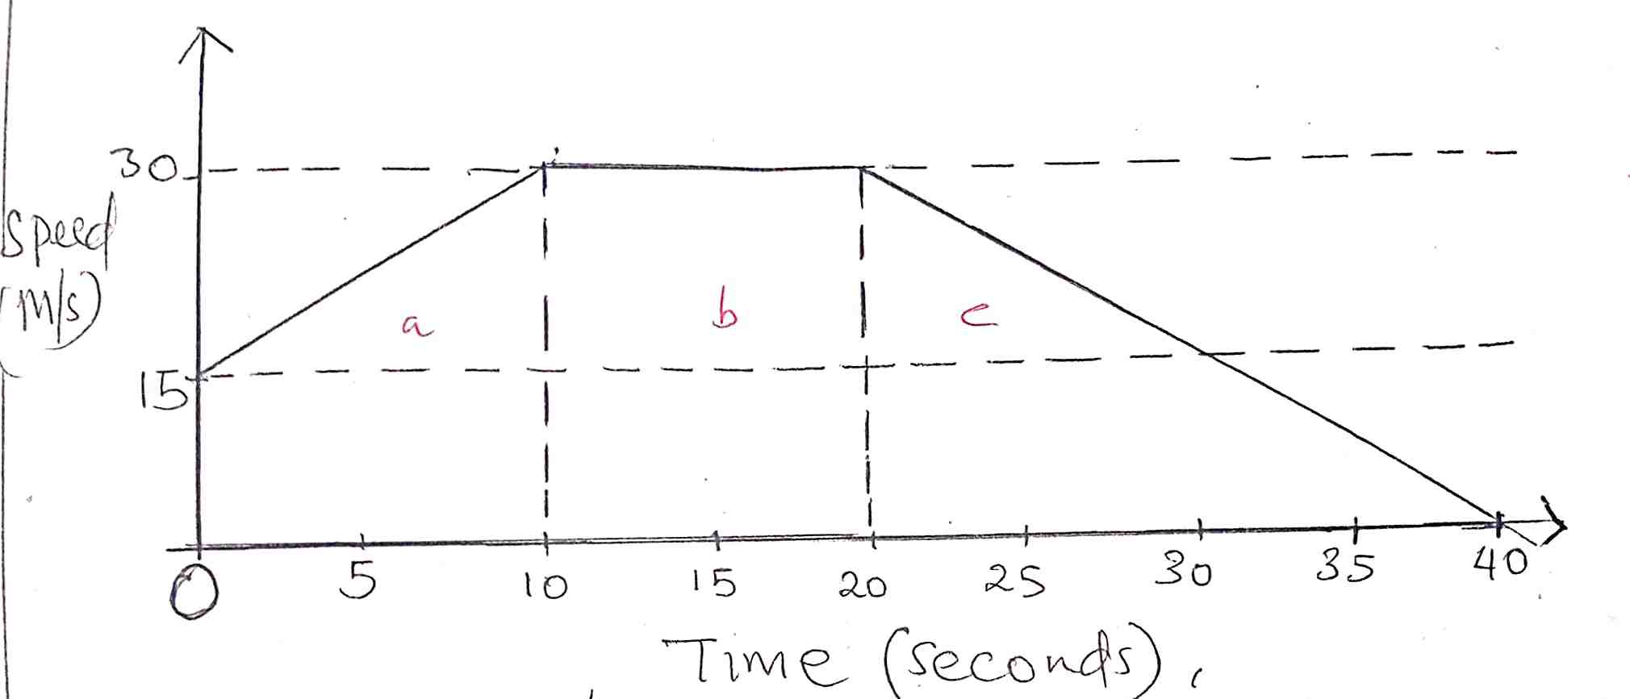

Area of a = ½ x 10 (15+30) area of c = ½ x 30 x 20
= 225m = 300m
Area of b = 30 x 10 total = 225 + 300 + 300
= 300m = 825m
M1-areas
M1-operation
A1

3
SECTION II
Answer any five questions in this section.
- A rectangular tank whose internal dimensions are 2.4m by 2.5m by 3.7m is two thirds full of juice.
a. Calculate the volume of the juice in litres. (3mks)
²/₃x 2.4 x 2.5 x 3.7
14.8m³
1m³ 1000L M1-vol
14.8m³ ? M1-convertion
14.8 x 1000 A1
14800 litres 3
b. The juice is parked in small packets in a shape of right pyramid with equilateral triangles of sides 20cm. the height of each packet is 15cm. a full packet is sold at kshs. 50 per packet.
Calculate:
- The volume of the juice in cm³ of each packet to the nearest whole number. (3mks)
Base area
= ½ ab sin C
= ½ x 20x20sin 60
= 173.21
Vol= ¹/₃ x 173.21 x 15 M1-base area of Δ face
=866.025 M1-vol. of pyramid expressed
=866cm³ A1
3
- The number of full packets of juice. (2mks)
1m³ = 1000000cm³
14.8m³ = ?
14.8 x 1000000cm³
No of packets = 14.8x10⁶
866
=17089.58 M1-devision
=17,089 A1- CAO whole (packets)
2
- The amount of money realized from the sale of juice. (2mks)
17089 x 50 M1-sales expressed
Sh. 854,450 A1
2
- The masses in kilograms of patients who attended a clinic on a certain day were recorded as follows.
67 | 49 | 57 | 58 | 69 | 58 | 39 | 61 | 51 | 47
38 | 59 | 46 | 52 | 60 | 72 | 59 | 49 | 54 | 52
69 | 62 | 58 | 67 | 63 | 59 | 65 | 58 | 49 | 44
49 | 41 | 70 | 58 | 54 | 60 | 60 | 59 | 42 | 41
79 | 52 | 51 | 48 | 54 | 59 | 62 | 73 | 48 | 54
- Starting with the class 35-39, make a frequency distribution table for the data. (2mks)
Mass | F | Tally | Mid (x) | fx | Cf
35-39 | 2 |  | 37 | 74 | 2
40-44 | 4 |  | 42 | 168 | 6
45-49 | 8 |  | 47 | 376 | 14
50-54 | 9 |  | 52 | 468 | 23
55-59 | 11 |  | 57 | 627 | 34
60-64 | 7 |  | 62 | 434 | 41
65-69 | 5 |  | 67 | 335 | 46
70-74 | 3 |  | 72 | 216 | 49
75-79 | 1 |  | 77 | 77 | 50
 | £f=50 |  |  | £fx=2775
B1-groups
B1- frequency & tally
2
- Calculate the mean mass. (3mks)
X=£fx
£f
= 2775
50 B1-column completed
=55.5kg M1
A1
3
ii) Calculate the median mass. (3mks)
m=L + ^{n}/₂ –cf x i
f

= 54.5 + 50/2 – 23 5
11

= 54.5 +0.91 B1-cf column
= 55.41 M1-values correctly substituted
A1
3
- On the grid provided draw a frequency polygon to represent the data. (2mks)

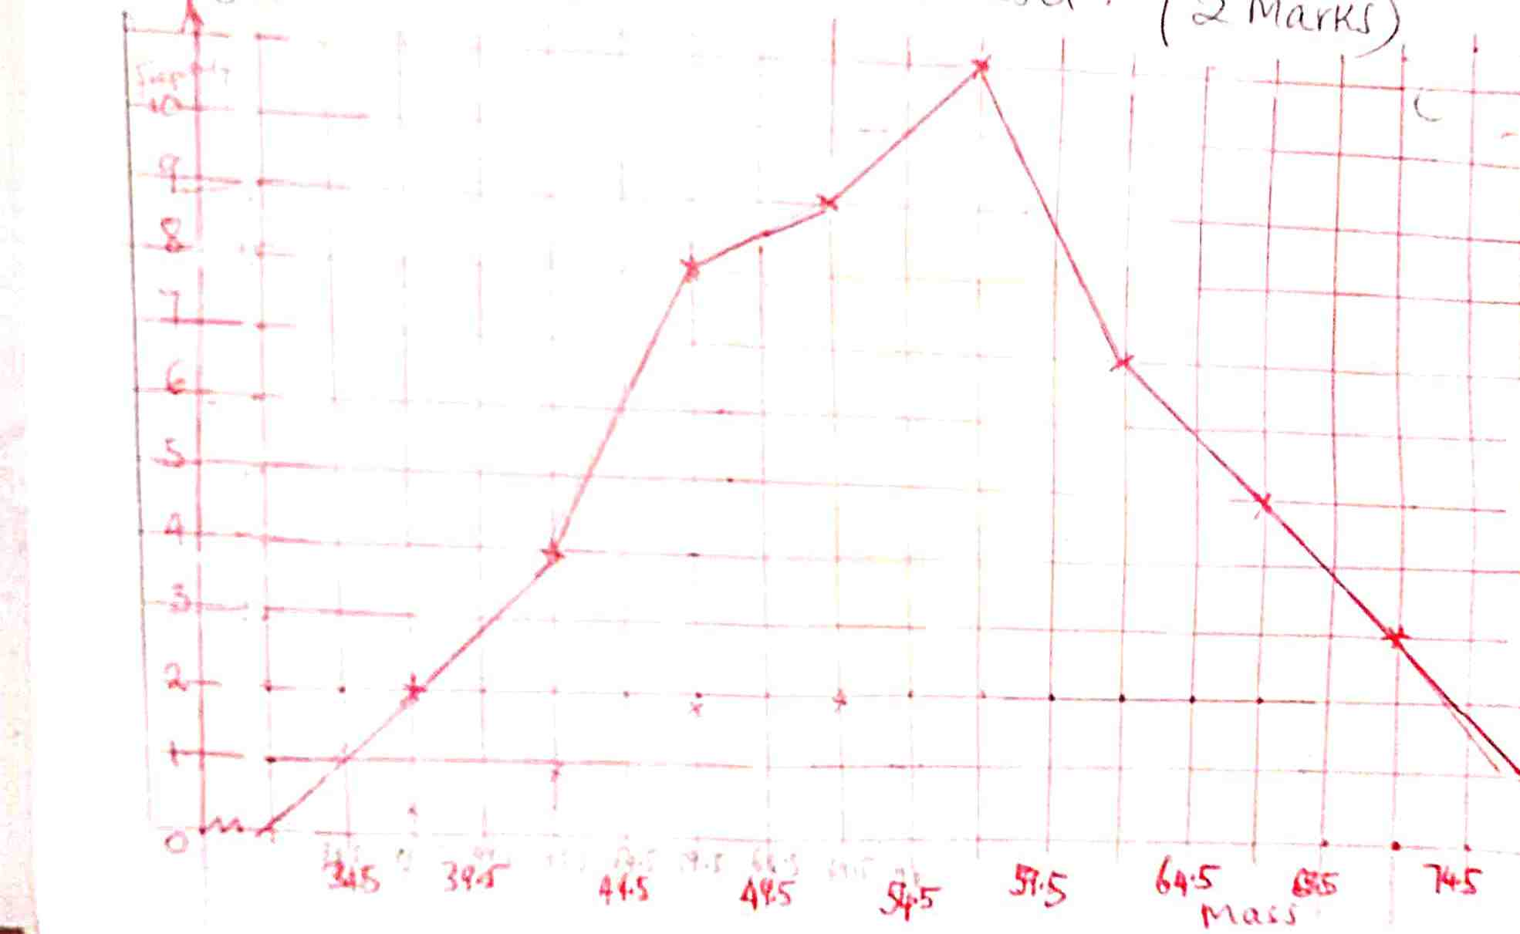
- The position vectors of A, B and C are 3i – 2j, -6i + 4j and -9i – 3j respectively.
- State the column vectors.
- AB (2mks)
AB= B-A
-6 - 3
4 -2

-9 M1
6 A1
2
- CB (2mks)
CB = B-C

-6 -9 = 3
4 -3 7 M1
A1
2
- Find the distance from A to C. (2mks)
AC = C-A

= -9 - 3
-3 -2

= -12
-1
/AC/ = (-12)² + ( -1)²

145
M1
= 12.04 units A1
2
- Find the coordinates of the midpoint of AC. (2mks)
3i + 9i - 2j + - 3j
2 2

-6i -5j
2 2

= -3i, -2.5j M1
Point (-3, -2.5) A1
2
- If point C΄ is the image of C under translation vector 1
-3
Find the co-ordinates of C΄. (2mks)

C + 1 = C΄
-3

-9 + 1 = -8
-3 -3 -6 M1 A1
2
C΄ = (-8, -6) or -8i -6j

- Complete the table below for the function y= x² – 3x + 6 in the range -2 ≤ x ≤ 8. (2mks)
X | -2 | -1 | 0 | 1 | 2 | 3 | 4 | 5 | 6 | 7 | 8
Y | 16 | 10 | 6 | 4 | 4 | 6 | 10 | 16 | 24 | 34 | 46
 | Y₀ | Y₁ | Y₂ | Y₃ | Y₄ | Y₅ | Y₆ | Y₇ | Y₈ | Y₉ | y_{n}

B2-all rates
- Use the trapezium rule with 10 strips to estimate the area bounded by the curve, y=x²- 3x + 6, the lines x = -2, x =8 and the x – axis. (3mks)
Let h=1
= ½ h Y₀ +Y_{n} +2 (y1+y2+…)
=0.5 16+46+2(10+6+4+4+6+10+16+24+34)
=0.5 (62+228)
=145 square units M1
M1
A1
3

- Use the mid – ordinate rule with 5 strips to estimate the area bounded by the curve, y = x² – 3x + 6, the lines x = -2, x = and the x- axis. (3mks)
A = h(y₁+y₂+……..y_{n})
= 2 (10 + 4 + 6 + 16 + 34)
= 140 sq units
M1
A1
2

- By integration, determine the actual area bounded by the curve y = x² – 3x + 6, the lines x = -2, x = 8, and the x – axis. (3mks)

Intergrate form -2 to 8 (x² – 3x +6 ).dx

x³ – 3x² +6x
3 2

8³ – 3 x 8² + 6 x 8 - -2³ – 3 x -2²-6x-2
3 2 2 2
(170.7 – 96 + 48) – (-4 -6-12) M1
122.7 + 22 M1
= 144.7 sq units A1
3

- The corner points A, B, C and D of a ranch are such that B is 8km directly East of A and C is 6km from B on a bearing of 30º. d is 7km from C on a bearing of 300º.
- Using a scale of 1cm to represent 1km, draw a diagram to show the positions of A, B, C and D. (4mks)
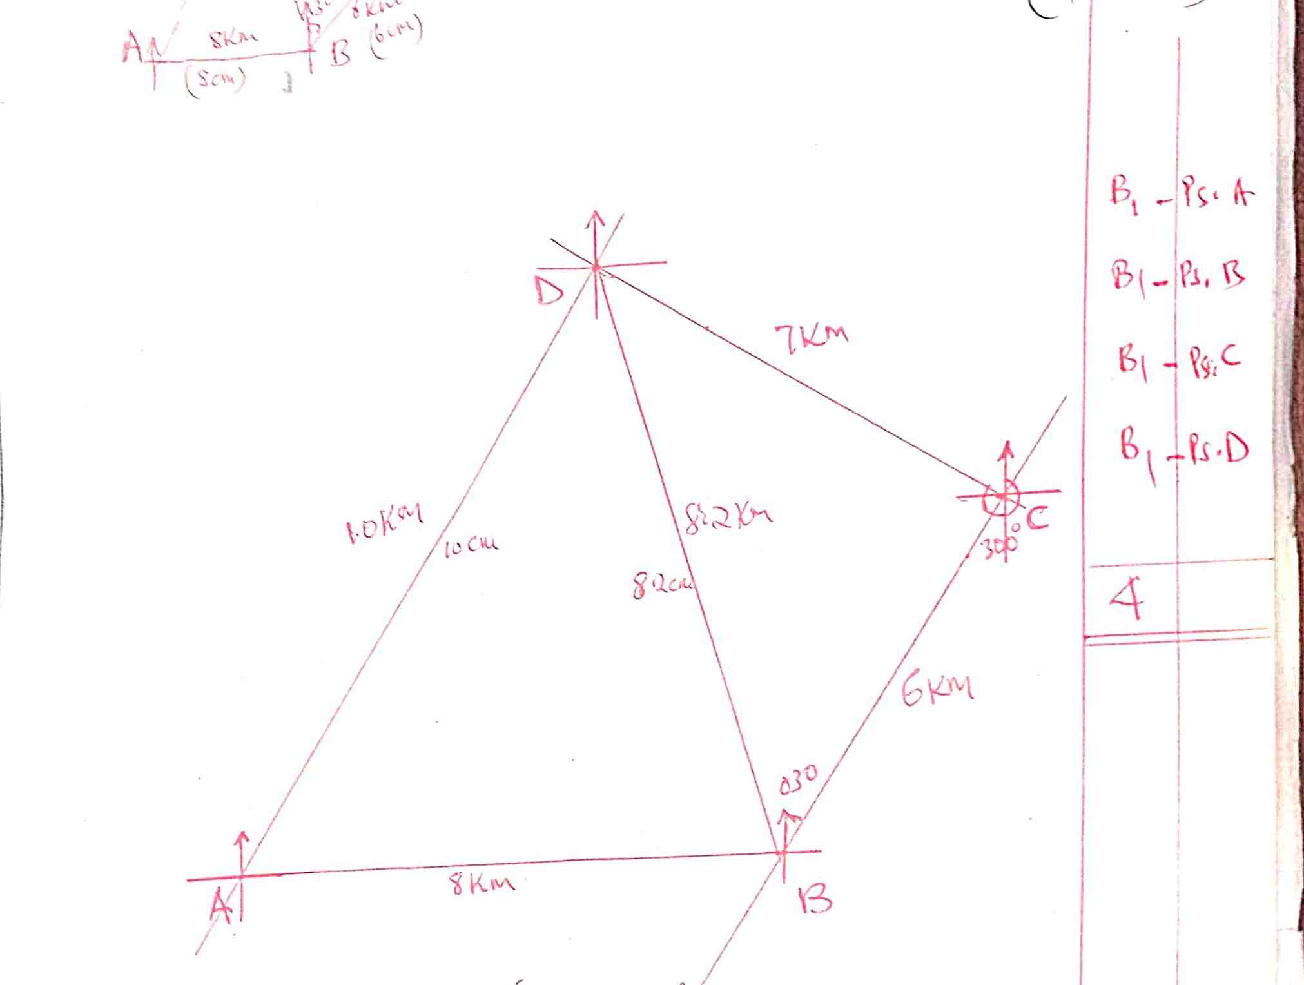

B1-PSA
B1-PSB
B1-PSC
B1PSD
4
- Use the scale drawing to determine:
- The bearing of A from D. (1mk)
= 180 + 30
= 201º
±1º B1
- The distance BD in kilometers. (2mks)
8.2cm
8.2 x 1km
=8.2km B1
±0.1 B1-conversion
2

- The perimeter of the ranch in kilometers. (3mks)
AD = 10cm = 10km
P = 8km + 6km +7km + 10km B1
=31km M1
A1
3

- Johana and Muchiru contributes Ksh. 150,000 and Ksh. 180,000 every year respectively for a business, after one year Jacob joined the business and contributed Ksh. 135,000.
- Calculate the ratio of their investment after three years of business. (3mks)
Muchiri’s contribution = 180000 x 3 = 540,000
Johana’s contribution = 150000 x 3 = 450,000
Jacob’s contribution = 135000 x 2 = 270,000

Ratio Johana: Muchiri: Jacob M1-contributions
= 450,000: 540,000: 270,000 M1-expression
= 5:6:3 A1-ratios simplified
3
- They agreed that 30% of the profits after 3 years be used to cater for the costs of running the businesses while the remaining would be shared proportionally. Calculate each person’s share if the profit after 3 years was shs. 240,000. (4mks)
30 x 240000 = 72000
100
Remainder = 240000 - 72000
= 168000
5:6:3
5 + 6 + 3 =14
Johana’s = 5 x 168000 = 60000
14

Muchiri = 6 x 168000 = 72000 M1-rem
14 M3-ratios each
Jacobs = 3 x 168000 = 36000 4
14
- If each re-invested their shares back into the business, find the new individual investment at the beginning of the fourth year. (3mks)
Johana’s = 450000 + 60000 = 510000 M2-additions
Muchiri’s = 540000 + 72000 = 612000 A1-all
Jacob’s = 270000 + 36000 = 306000 3

- The figure below shows the end wall of a building with the axes shown and 1M as the unit of measurement. The roof line is given by y= a + bx², where a and b are constants.
- State the value of a. (1mk)
A = y intercept
A= 15 B1

- Calculate the value of b. (3mks)
Y = 15 + bx²
At x = -10, y=9 (-10,9)
9= 15 + (-10²)b
9= 15 + 100b

100b = 9 -15
= -6 M1-for point (-10,9)
B= ⁻⁶/₁₀₀ = ⁻³/₅₀ M1- equation
Or = 0.06 A1
3

- Calculate the values of y for x = 2, 4, 6, 8 and compete the table below. (2mks)
X | -10 | 0 | 2 | 4 | 6 | 8 | 10
Y | 9 | 15 | 14.76 | 14.04 | 12.84 | 11.16 | 9

Y = 15 – 3x²
50

- Calculate the area of the wall. (4mks)
10 15 – 3x² dx
50
-10
10

15x – 3x³
50x3
-10

15 x 10 – 10³ - -15x10-(70³)
50 50
M1-units
(150-20) – (-150 + 20) M1-intergration
130 - - 130 M1-units subst
= 260sq units A1
4

- A ball is thrown upwards and its height after t seconds is 5 meters, where s = 20t – 5t². Find
- The greatest height reached and the time when it is reached. (3mks)
Velocity (v) = ds
dt
v = 20-10t
at maximum, v=0
20 – 10t =0
T=2 seconds M1 for ^{ds}/_{dt}
S=20(2) – 5 (2²) M1
= 40 – 20 A1
=20m 3

- The time when it returns to the original level. (3mks)
At original level1 s=0
20t – 5t²=0
5t (4 – t) =0 M1-eqn
T=0 or 4 sec M1
After 4 seconds A1
3
- Its velocity after 3 seconds. (2mks)
V = 20 – 10t
V = 20 – 10(3)
= 20-30 M1-substuted
= -10m/s A1
2

- Its acceleration during the throw. (2mks)
If V= 20-10t
Acceleration = dv M1 for ^{dv}/_{dt}
At M1
= -10ms⁻² 2

