MANGU HIGH SCHOOL TRIAL 2 MOCK 2021
233/2 – CHEMISTRY PAPER 2 - MARKING SCHEME

- (a) (i) Alkali metals
      - Energy required to remove an electron from an atom of an element in its gaseous state.
      - “P” has the smallest ionic radius therefore, the outermost electrons are most strongly attracted to the nucleus, hence more energy is required to remove this electron.
      - Melts because the reaction is exothermic. Hissing sound because of the production of hydrogen gas. Float because it is less dense than water. Moves about due to propelling effect of escaping hydrogen.

  - A strong base ionizes completely in water producing more OH⁻ ions e.g. KOH and NaOH. A weak base ionizes slightly producing few OH ions e.g. NH₄OH, Ca(OH)₂ and Mg(OH)₂.

  - (i) Reaction between H⁺ ions from the acid and OH ions from bases to form 1 mole of water.
H+_{(aq)} + OH_{(aq)} H₂O(l)
      - Add 200cm³ of 2M nitric acid to 200cm³ of 2M sodium hydroxide. Heat the mixture so as to make it saturated / concentrated. Allow the mixture to cool for crystals to appear. Filter / decant to obtain the crystals.

      - 2NaNO_{3(s)} 2NaNO_{2(aq)} + O_{2(g)}

- (a) (i) Anhydrous calcium chloride / silica gel.1
      - To remove carbon (IV) oxide from air1 or free air from CO₂.
      - 2Cu(s) + O_{2(g)} 2CuO_{(S)} 1
      - Unreacted oxygen, noble gases e.g. Argon. 1
      - It has a very low boiling point of -196⁰C.

- (i) Concentrated sulphuric VI acid / H₂SO₄ reject concentrated sulphuric acid.
(ii) KNO_{3(s)} + H₂SO_{4(l)} HNO3(g) + NaHSO4(aq)
(iii) It is decomposed by light1 to brown nitrogen (IV) oxide water and oxygen. 1

- The reaction between copper metal and 50% nitric V acid produces colourless nitrogen II oxide gas which is further oxidized by atomospheric oxygen to brown fumes of nitrogen IV oxide.

OR
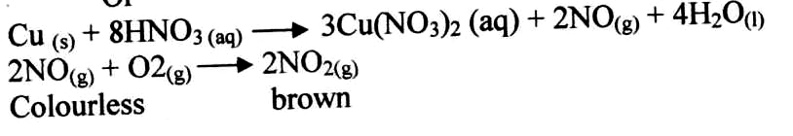

- (a) Halogens

(b) They attract electrons into the outer energy level by its nuclear charge during reaction. The atomic radii increase down the group due to the successive additional energy level. Therefore the outer most energy level of iodine increasingly get further away from the nucleus than for bromine hence nuclear attraction for electrons grows weak for iodine than bromine.

(c) (i) NaOH_{(aq)} and H_{2(g)}

(ii) 2Cl⁻_{(aq)} Cl_{2(g)} + 2e

- (i) Temperature of 60⁰C // heat.
(ii) NaClO₃ : Cl₂ = 1:3

Moles of NaClO₃ = ¹/₃ x moles of Cl₂
= ¹/₃ x 206,000
24
= 2861

NaClO₃ = 23 + 35.5 + 48 = 106.5g

Mass of NaClO₃ = 2861 x 106.5 = 304.7kg
1000

Or 3047000g

(e) (i) Manufacture of HCl acid.
(ii) Manufacture of Bleachants // or Bleaching agents.
(iii) Manufacture of plastics PVC.

- (a) (i) GRAPH OF COUNTS PER MINUTE AGAINST TIME FOR IODINE – 128
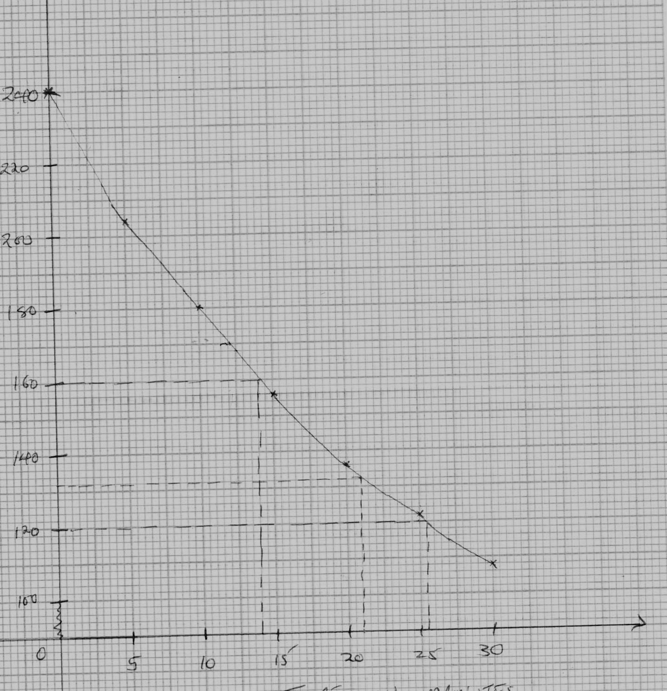
TIME IN MINUTES

(ii) 26 minutes +2 (must be shown on the graph).

(iii) 132 + 1

(iv) 14 minutes + 1

(b) (i) Change in mass of isotopes. (1mk)
232 – 216 = 16
4 4
Number of He Particles = 16 = 4 He
2 4 2
4 – particles
Change in atomic number.

90 – (4 x 2) = 90 – 8 = 82 – 83 = -1
o
1 e => an Beta particle.
-1

(ii) 232 216 4 0
TH Bi + 4 He e
90 83 2 -1

(c) (i) A – Beta (½ mks)
B – Gamma rays (½ mk)
C – Alpha (½mk)

(ii) I – Gamma rays (B) (½mk)
II – Beta particle (A) (½mk)
III – Alpha particle (C) (½mk)

- (a) Electrolytic1/Electrolysis

(b) Al₂O₃. 2H₂O1

(c) (i) Iron (III) oxide1
Silicon (IV) oxide1

(ii) NaOH is added to SiO₂

(d) To reduce M.P of Al₂O₃ and to reduce on the cost.

- Oxygen produced at anode react with carbon to form CO₂.

- It forms a protective layer of Al₂O₃ on its surface.

- (a) (i) A A²⁺_{(aq)} + 2e
B²⁺_{(aq)} + 2e B_{(s)}

(ii) A_{(s)} + B²⁺_{(aq)} A²⁺_{(aq)} + B(s)

(iii) E red – E oxid
-0.13 – (-0.76) = + 0.63

(iv) Introduces K⁺ and NO₃⁻ replace the ions consumed at electrodes.

(v) Insoluble PbCl₂ is formed.

(b) (i) Concentrated sodium chloride / brine.
(ii) Platinum.
(iii) - Soap
- glass
- bleaching agents
(iv) - Expensive
- Poisonous
(v) 2Na/Hg + 2H₂O 2NaOH + H₂ + Hg

(vi) 24 litres 2 x 40g of NaOH

100C 100 x 2 x 40
24

= 333.333g

- (a) Cotton / silk / cellulose / sisal (any one) – 1mk)

(b) - Last longer / durable / stronger.
- Less easily attacked by acids and alkalis.

(c) (i) Hydrogen gas (1mk)

(ii) (a) CH₃COOCH₂CH₃ - Ethylethanoate. (1mk)

(b) CH₄ – Methane

(iii) Alkylalkanoates

(iv) Cl

Cl – C – C

Cl

(v) Tetrachloromethane / Chloroform

