MANGU HIGH SCHOOL TRIAL 2 MOCK 2021
232/2 – PHYSICS PAPER 2 - MARKING SCHEME

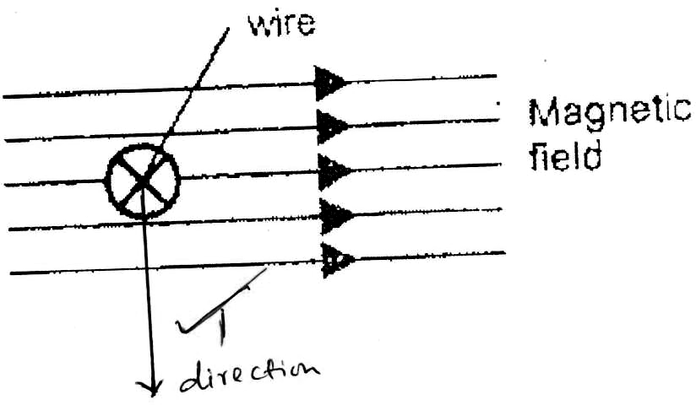

- Earthing machines using spikes.✓1

- P.d across R = 6 – 0.14

I = 0.14 = 0.07Amps✓1
2
R = V = 6 – 0.14
I 0.07

= 83.71Ω✓1

- (a) Permanent magnet. ✓1
(b) Magnetic material. ✓1

- (a) Distance = speed x time
= 330 x 4
= 1320m
(b)
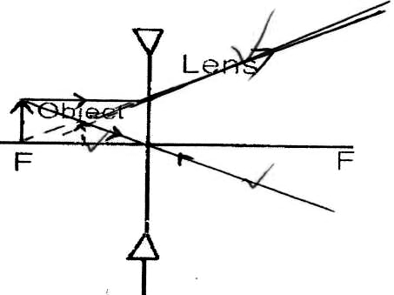

- P = 1✓1 = 1 = -10 Diopters✓1
F -0.1

- X – Plates✓1

- R₁ = V² R₂ = ^{V}/₂ ² R₁ = V² + V²
P 2P R₂ P 8P
= 8
- (i) Fringes of light
(ii) Central white fringe and fringes of different colours on either side of the central fringe.

- To the right✓1
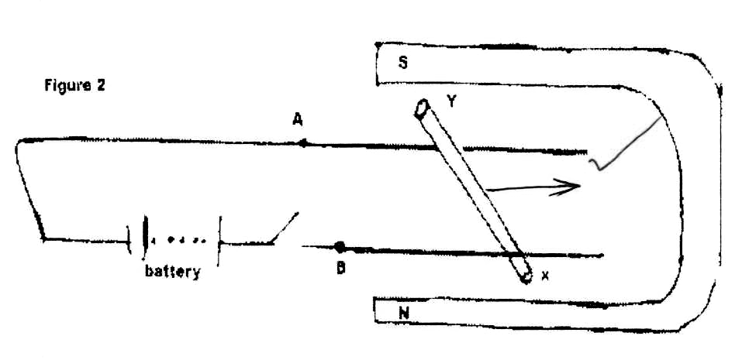
- When the wire is positioned at right✓1 angles to the magnetic field.

- Soft x-rays✓1 are produced because lower EHT results in slowly moving electrons hence✓1 low energy electrons.

- Q = CV
The area under✓1 the graph gives the energy stored in the capacitor.
Area = 6 x 10⁻⁶ x 20✓1
= 1.2 x 10⁻⁴J✓1

- (a) (i) A graph of current against voltage,

(ii)
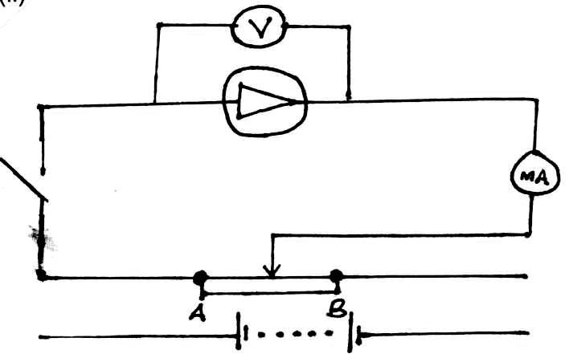
(b) The atoms that introduce holes in the pure semiconductors.

- (i) - During the first half cycle D₁ is forward biased while D₂ is reverse biased.
        - The path taken by current is D₁, Y R Z.
        - During the next half-cycle D₂ is forward biased while D₁ is reverse biased and the path of the current is Q D₂ Y R Z.
        - During both cycles, current flows through the resistor in the same direction.
(ii)
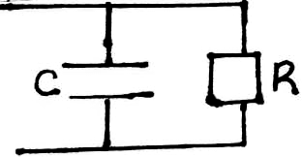

(iii) Smoothen the output signal.

(iv)
V (volts)

Time (s)
- (a) Position A - Alpha – heavy, less deflected in the field.
B - Gamma – no deflection just a ray
C - Beta – lighter, deflected more in the field.

- (i) Argon gas – ionized by the radiation.
Bromine – quenching agent.
(ii)
- When a radioactive substance is placed in front of the window, the emitted radiations enter the tube through the window and ionize the argon gas.
- The negative ions move towards the anode while the positive ions move towards the cathode.
- As ions accelerate, they collide with more particles on their paths, resulting in further ionization (Avalanche of electrons).
- A pulse current flow. A corresponding pulse voltage is registered across the resistor R.
- These currents can be amplified and if passed through a loudspeaker, clicks are heard – or a rate meter.
(iii)
- Used to monitor the function of thyroid gland.
- Used to trace blood clots.
- Used to kill harmful tissues such as cancerous cells.
- (i) Increasing wavelength / reducing frequency.
(ii) Travel at the speed of light c.

- (a) (i) Joules second (Js)
(ii) Thresh-hold frequency
(iii) See graph
(iv) Radiation with simple wavelength.

(b) K.E = hf – hf_{o}

= 1.6 x 10⁻¹⁹ = 6.6 x 10⁻³⁴ x 7.5 x 10¹⁴ – 6.6x10⁻³⁴f_{o}
6.6 x 10⁻³⁴ f_{o} = 3.35 x 10⁻¹⁹
6.6 x 10⁻³⁴ 6.6 x 10⁻³⁴
f_{o} = 5.0758 x 10¹⁴Hz.
- (a) Change in velocity. ✓1
(b) (i) _{d}η_{R} = _{d}η_{a} . _{a}η_{R}✓1 OR
1 x 1.75✓1 _{d}η_{R} ₌ η_{R}
2.4 η₁
= 0.729167✓1 = 1.75 = 0.7292
2.4
(ii) _{R}η_{d} = _{R}η_{a} . _{a}η_{d}
1 x 2.4
1.75
= 1.371
_{R}η_{d} = 1
Sin c ✓1
Sin c = 1
_{R}η_{d}

c = sin⁻¹ 1
_{R}η_{d}

= sin⁻¹ 1 or sin⁻¹ 1.75
1.371 2.4

= 46.8⁰✓1
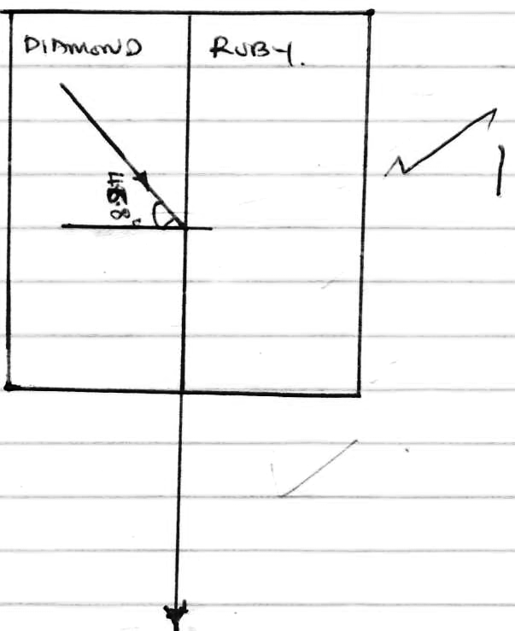
(c) (i) At A light undergoes refraction. ✓½
At B light undergoes total internal refraction. ✓½
(ii) C - Violet✓1
D – Red ✓1

- (a) (i) The umbra✓ remains the same.
(ii) The umbra becomes smaller. ✓
(iii) The umbra becomes greater. ✓

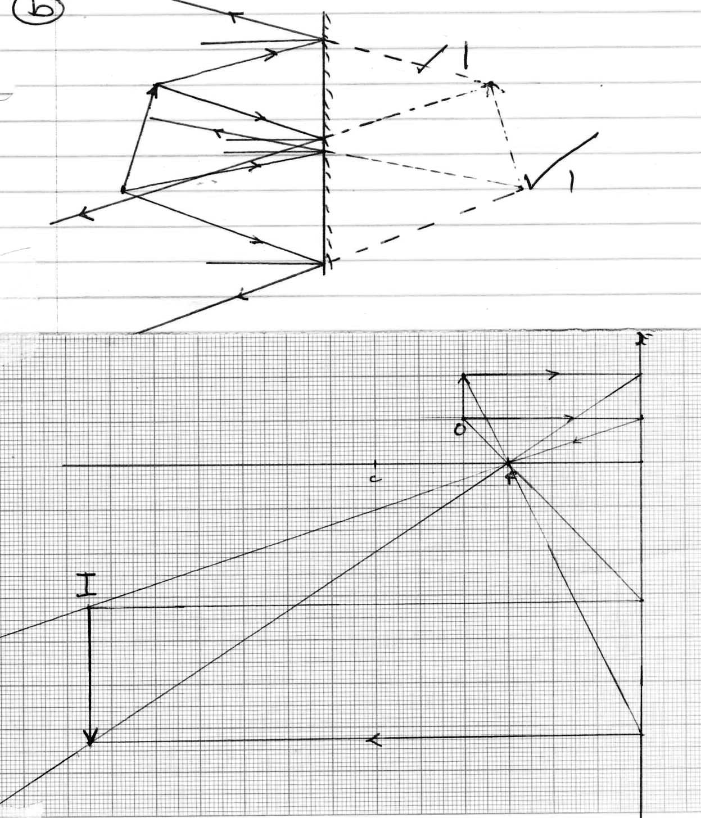
Produces parallel beam of light. ✓1
- (a) To earth the device to avoid electrocution. ✓1
(b) Lighting circuit draws a smaller current than cooker circuit. ✓1

(c) (i) V_{P} = N_{P}✓1
V_{S} N_{S}
V_{S} = V_{P}N_{S}
N_{P}
= 400 x 300✓1
6000
= 20V✓1

(ii) Power input = Power output
600W = I_{P} x 400V
I_{P} = 600
400
= 1.5A✓1
(iii) P = I_{S}P_{S} I_{S} = 600✓1
600 = I_{S} x 20 20
= 30A✓1

