NAME ADMNO CLASS
121/1
MATHEMATICS
Paper 1
2½ Hours

MECS CLUSTER JOINT EXAMINATION
FORM FOUR END OF THE TERM TWO EXAMINATION 2021
MATHEMATICS

INSTRUCTIONS TO CANDIDATES
- Write your name, index number and class in the spaces provided above.
- The paper contains two sections: Section I and Section II.
- This paper contains 14 PRINTED pages make sure all PAGES ARE PRINTED and NON IS MISSING
- Answer ALL the questions in Section I and ANY FIVE questions from Section II.
- All working and answers must be written on the question paper in the spaces provided below each question.
- Marks may be awarded for correct working even if the answer is wrong.
- Negligent and slovenly work will be penalized.
- Non-programmable silent electronic calculators and mathematical tables are allowed for use.
For examiners use only
Section I
1 | 2 | 3 | 4 | 5 | 6 | 7 | 8 | 9 | 10 | 11 | 12 | 13 | 14 | 15 | 16 | Total

Section II
Grand
Total
17 | 18 | 19 | 20 | 21 | 22 | 23 | 24 | Total

SECTION I (50 MARKS)
Answer all the questions in this section in the spaces provided.

- (a) Evaluate 94344 – 36425 ÷ 5 $\left[1mark\right]$

(b) Write the total value of the digit in the thousands place of the result obtained in (a) above $\left[1mark\right]$

- In a game park $\frac{1}{5}$ of the animals are rhinos and ¾ of them are zebras. $\frac{2}{3}$ of the remaining animals are lions and the rest are warthogs. Find the fraction of warthogs in the game park. $\left[3marks\right]$

- The volume of a cube is $2744cm^{3}$. Calculate the length of the diagonal of a face of the cube giving your answer in surd form. $\left[3marks\right]$

- Without using mathematical tables or a calculator, evaluate

${27}^{\frac{2}{3}}×{\left(\frac{81}{16}\right)}^{-\frac{3}{4}}$ $\left[3marks\right]$

- Using ruler and a pair of compasses only, construct triangle ABC in which AB = 6cm and angle ABC = 105⁰ and angle BAC = 45⁰. Measure length of BC. $\left[3marks\right]$

- An empty specimen bottle has a capacity of $300ml$ and a mass of $280g$. Calculate the mass of the bottle when it is full of a liquid whose density is $1.2g/cm^{3}$. $\left[3marks\right]$

- The figure below shows a sketch of a solid cuboid EFGHIJKL. Complete the sketch. $\left[2marks\right]$
E
H
G
L
K
J

I

- Find the rate per annum at which a certain amount doubles after being invested for a period of 5 years compounded semi-annually $\left[3marks\right]$

- The sum of the interior angles of a regular polygon is 40 times the size of the exterior angle.
(a) Find the number of sides of the polygon. $\left[3marks\right]$

(b) Name the polygon $\left[1mark\right]$

- The data below shows the number of pupils in Nairutia Primary School

42 | 43 | 48 | 40 | 46 | 42 | 44 | 48 | 39 | 40 | 42
41 | 47 | 46 | 45 | 49 | 45 | 42 | 40 | 38 | 39 | 40
46 | 47 | 42 | 40 | 41 | 43 | 44 | 45 | 46 | 48
- Using a class size of 2 organize the data in a grouped frequency table. $\left[2marks\right]$

- Determine the mean of the data. $\left[2marks\right]$

- Given that q = 5t – 3f where t = $\left(\begin{matrix}-2 \\ -3\end{matrix}\right)$ and f = $\left(\begin{matrix}1 \\ -2\end{matrix}\right)$ find:
˜
˜
˜
˜
˜
(a) the column vector q $\left[2marks\right]$
˜

(b) Given that T^{I} (3,2) is the image of T (0,-2) under a translation, find the translation. $\left[1mark\right]$

- Given that a = -5 b = 3 and c = -$\frac{1}{3}$, evaluate: $\frac{{5a}^{2}- 2b-4c}{\frac{1}{3}\left(b^{2}+2a\right)}$ $\left[3marks\right]$

- Find the value of x in the equation in the range listed below.
0º ≤ x ≤ 180º $\left[3marks\right]$

- Simplify the expression

$\frac{{4t}^{2}-{25a}^{2}}{{6t}^{2}+9at-{15a}^{2}}$ $\left[3marks\right]$

- The figure below represents the speed-time graph of a tuktuk. Use it to answer the questions (a) and (b)
10
20
10
20
30
Time (s)
Speed (m/s)

- Calculate the acceleration of the tuktuk. $\left[2marks\right]$

- Find the total distance travelled for the whole journey $\left[2marks\right]$

- A farmer has a piece of land measuring 840m by 396m. He divides it into square plots of equal size. Find the maximum area of one plot. $\left[3marks\right]$

SECTION (50 MARKS)
Answer any five questions in this section in the spaces provided.

- In the year 2001 the price of a sofa set in a shop was KSh. 12,000
(a) Calculate the amount received from the sales of 240 sofa sets that year. $\left[2marks\right]$

(b) In the year 2002 the price of each sofa set increased by 25% while the number of sets sold decreased by 10%.
(i) Calculate the percentage increase in the amount received from the sales $\left[3marks\right]$

(ii) If at the end of the year 2002, the price of each sofa set changed in the ratio 16:15.
Calculate the price of each sofa set in the year 2003. $\left[2marks\right]$

- The number of sofa sets sold in the year 2003 was p% less than the number sold in the year 2002. Calculate the value of P given that the amount received from the sales in the year were equal $\left[3marks\right]$

- A line L passes through points (-2,3) and (-1,6) and is perpendicular to a line P at (-1,6)
(a) Find the equation of L. $\left[2marks\right]$

(b) Find the equation P in the form ax + by = c where a, b and c are constants. $\left[2marks\right]$

- Given that another line Q is parallel to L and passes through point (1,2), find the x and y - intercepts of Q. $\left[3marks\right]$

- Find the point of intersection of lines P and Q. $\left[3marks\right]$

- In the figure below (not drawn to scale) AB = 8cm, AC = 6cm, AD = 7cm, CD = 2.82cm and angle CAB = 50⁰.
D
C
A
B
7cm
8cm
2.82cm
50⁰
6cm

Calculate to 2 decimal places
- the length BC $\left[3marks\right]$

- the size of angle ABC $\left[2marks\right]$

- the size of angle CAD $\left[3marks\right]$

- the area of triangle ACD $\left[2marks\right]$

- The coordinates of a triangle ABC are A(1, 1) B(3, 1) and C (1, 3).
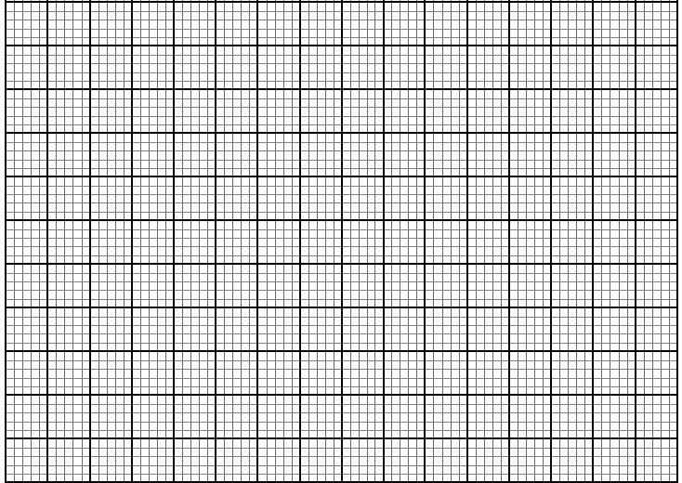
(a) Plot the triangle ABC. $\left[1 mark\right]$

(b) Triangle ABC undergoes a translation vector$\left(\begin{matrix}2 \\ 2\end{matrix} \right)$. Obtain the image of A' B' C ' under the transformation, write the coordinates of A' B' C'. $\left[ 2 marks\right]$

(c) A' B' C' undergoes a reflection along the line X = 0, obtain the coordinates and plot on the graph points A" B" C", under the transformation. $\left[2 marks\right]$

(d) The triangle A" B" C" , undergoes an enlargement scale factor -1, centre origin. Obtain the coordinates of the image A'" B"' C"'. $\left[2 marks\right]$

(e) The triangle A"' B"' C"' undergoes a rotation centre (1, -2) angle 120⁰. Obtain the coordinates of the image A^{iv} B^{iv} C^{iv}. $\left[ 2 marks\right]$

(f) Which triangles are directly congruent. $\left[1 mark\right]$

- Three warships $P, Q and R$ leave port X at 9:00am, ship P sails at a steady speed on a bearing of 070⁰, 100km from port X, while ship Q sails on a bearing of 320⁰, 80km from X. Ship R is on a bearing of 150⁰ from port X and due south of ship P.

- Use scale drawing to show the position of $P,Q,R and X$ $\left[4marks\right]$

b) Use the scale drawing to determine
i) The distance and bearing of ship P from ship Q $\left[2marks\right]$

ii) The distance of ship R from port X $\left[2marks\right]$

iii) The distance of ship R from ship P $\left[2marks\right]$

- A rectangular tank whose internal dimensions are $2.04m by 1.68m by 26.4 m$ is $\frac{7}{8}$full of milk
- If the tank is made of metal of thickness $3mm.$ Calculate the external volume of
the tank in $m^{3}$ when closed.
$\left[3marks\right]$

- Calculate the volume of milk in the tank in cubic metres. $\left[2marks\right]$

- The milk is to be packed in small packets. Each packet is in the shape of a
Right - Pyramid on an equilateral triangular base of side $19.2cm$. The height of each packet is $13.6 cm$. Full packets obtained are sold at $kshs. 35$ per packet. Calculate;
i) The volume of milk, in cubic centimeters contained in each packet to 4 significance figures. Hence find the number of full packets. $\left[3marks\right]$

ii)The exact amount that will be realized from the sale of all the packets of
milk. $\left[2marks\right]$

- (a) Find the inverse of the matrix $\left[2marks\right]$ $\left[\begin{matrix}2 & 5 \\ 4 & 3\end{matrix}\right]$

(b) A transport company has two types of vehicles for hire: Lorries and buses. The vehicles
are hired per day. The cost of hiring two lorries and five buses is Sh. 156,000 and that
of hiring 4 lorries and three buses is Sh. 137,000.
(i) Form two equations to represent the above information. $\left[2marks\right]$

(ii) Use matrix method to determine the cost of hiring a lorry and that of hiring a bus.
$\left[3marks\right]$

(c) Find the value of x given that $\left[\begin{matrix}2x-1 & 1 \\ x^{2} & 1\end{matrix}\right]$ is a singular matrix $\left[3marks\right]$

24. a) (i) Find the co-ordinates of the stationary points of the curve y = x³ – 3x + 2. $\left[4marks\right]$

(ii) For each stationary point determine its nature $\left[2marks\right]$

(b) Determine the y-intercept $\left[2marks\right]$

(c) In the space provided sketch the graph of the function y = x³ – 3x + 2 $\left[2marks\right]$

